University of Bath XX30191

HOUSEHOLD INCOME AND CARBON EMISSIONS

**PRACTICAL SESSION**

Peter Harper

On an international scale it is well known that carbon emissions are positively correlated with GDP. This is problematic because all nations want to grow and get richer. To do this and not increase carbon emissions demands ‘decoupling’ of emissions and economy, or in other words switching from higher to lower carbon intensity while keeping everything growing. It is not proving easy.

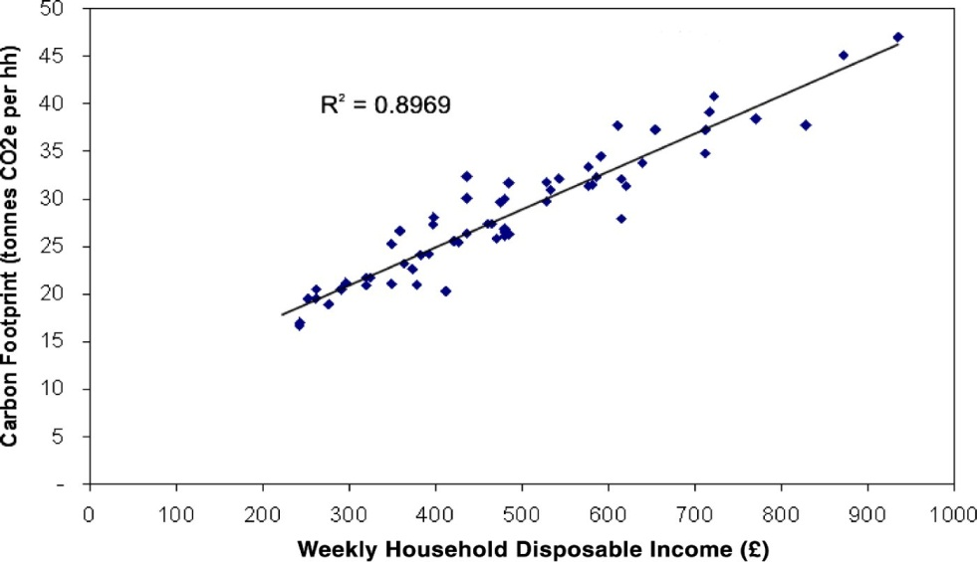It is not so widely remarked that the same is likely to be true of individuals, or more precisely *households*, the main locus of consumption. Usually households aspire to get richer. Will this tend to increase their carbon emissions? There is every reason to think so, yet until recently the literature has been remarkably silent on the matter. What data we have suggests a direct straight-line relationship with a slope of about 0.3, as shown in the chart at right (from Minx *et al*., 2009).

Minx J.C., *et al*., Understanding Changes in CO2 Emissions from Consumption 1992-2004: a

structural decomposition analysis. DEFRA. (2009).

Rather similar results have been obtained by Gough *et al*. (2012) and Buechs and Schnepf (2013).

These authors have mapped out the average cases, but for each income point there must be another distribution of high- and low-emitting households. How low could these be? Or how high?

The full distribution within this income/emissions space has not been studied, and we shall carry out some explorations in the practical.

Why this could be significant is that if some households are potentially much ‘better’ than average, we want to know what they are doing right, and whether it translates into a viable pattern of family life. And conversely, what the bad ones are doing wrong. How ‘bad’ can a household get? And are these effects strong enough to ‘decouple’ income and emissions -- to overcome the apparently malign effects of simply being rich?

You should have a look at the ‘Household carbon accounting lecture notes’ for background methodology. Figure 7 in the notes identifies four hypothetical groups of householders, two rich, two ‘poor’, one of each pair being low-carbon emitters for their income, one high emitters. This is illustrated in the graph below, showing principal emission classes.

Emission intensity, kgCO2e/£

Expenditure, £

High-income minimisers

High-income maximisers

Low-income minimisers

Low-income maximisers

KEY:

We could probably do better than this, perhaps with six categories rather than four. I would like the class to divide into six groups, each of which will ‘adopt’ a type of household and explore it. To simplify everything the households are considered to consist of just two adults and one pre-teen child.

There are three ‘income’ categories:

* the 2nd decile with a disposable (after tax and benefits) expenditure of £12000 a year;
* ‘average’ with a disposable income of £30000 a year; and
* 10th decile with a disposable income of £70000 a year.

We know quite a lot about the *average* spending and emission habits of these groups, because the academic studies have investigated them. We do not know much about the ‘outliers’: groups far from the average case. In this exercise we will model carbon maximisers and carbon minimisers for each of the three income categories. Maximisers will constantly make ‘high-carbon’ choices, while minimisers will strive to get their total emissions as low as possible.

You will need to form six groups, each with a computer, and choose one of the six cases. Then work your way through the calculator tool, making choices characteristic for that group. The constraint will be income: you cannot exceed your income, yet you have to spend everything. So you will need to construct an approximate annual budget, showing how much is being spent on what.

To help with this, you will be provided with statistical data from the Office of National Statistics, showing how much is typically spent on various categories of goods and services by different income classes. This should help you be ‘realistic’ and keep within your budget. You can also do we searches and use your own knowledge of ‘what things cost’. You might find you need several iterations to reconcile your various choices wiuth the budget and derive a realistic carbon footprint and fingerprint.

You should be able to create a suitable fingerprints using the calculator tool’s graphics, but you might have other ideas on how your results can be presented.

When you have done the number-crunching, I want you to create a realistic picture of daily life within the household you have modelled. Give your family a name. You will have a chance to explain to the class how they developed their pattern of life. Of course we are particularly interested in ‘where the shoe pinches’: the difficulties that might arise in trying to realise some of these domestic scenarios.

Collectively, we should be able to suggest some points in the income-emissions space that could exist in reality. It would be a task for further research to try and find actual examples of such households, or to find households willing to ‘live out’ some of the theoretical possibilities.

I have in fact done a certain amount of this kind of participant-observation research, and some informal results are discussed in Harper (1999). For those who are interested I’ll put a copy on the VLE. Vaze (2010) did something similar, and his book is in the university library.

REFERENCES

Minx, J.C., Baiocchi, G., Wiedmann, T. and Barrett, J. (2009) *Understanding Changes in CO 2 Emissions from Consumption 1992-2004: A Structural Decomposition Analysis,* Report to the UK Department for Environment, Food and Rural Affairs by Stockholm Environment Institute at the University of York and the University of Durham, DEFRA, London, UK.

Gough, I., *et al*. (2012): *The Distribution of Total Greenhouse Gas Emissions by Households in the UK, and some implications for Social Policy*. Centre for the Analysis of Social Exclusion, Paper 152.

Buechs, M., and S. Schnepf (2013). Who emits most? Associations between socio-economic factors and UK households’ home energy, transport, indirect and total CO2 emissions

Accepted for publication by *Ecological Economics*, forthcoming 2013.

Harper, P. “Techno-Anthropology in the Home”, *Radical Statistics* No. 71, Summer 1999.

Vaze, Prashant. *The Economical Environmentalist*. Earthscan 2010.

SOME RESULTS

You might be interested to know more about how the results of the class exercise compare with the average case, and with other similar exercises.

The graph summarises some results I have obtained over the last few years.

The purple line is the average relationship between household income and emissions, as reported by Gough *et al*. (2010). The other points are ‘outliers’ generated either by group simulations such as the one you undertook, or investigations of self-proclaimed ‘carbon-minimising households.

Your results are the large shadowed lozenges with black borders. We should not perhaps expect tidy data from an exercise such as this, but as it happens your results form an elegant and coherent pattern reflecting the roughly ‘megaphone shape’ of outlying emissions that we have observed previously.

Well done, and thanks to all for a course with plenty of dialogue: I’m learning too. Good luck in the exams.