PLANTING UP THE RAILWAY
A Bizarre Landscape Challenge

Peter Harper
Centre for Alternative Technology

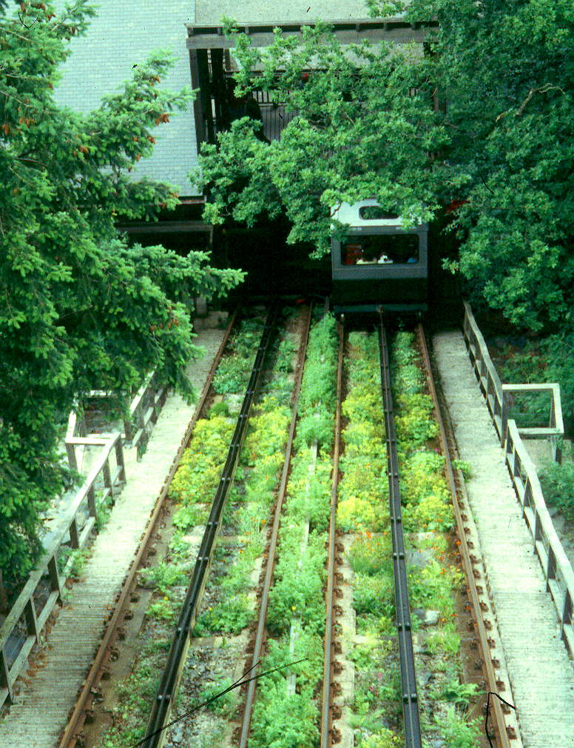
Railways and plants are supposed not to mix. A lot of gravel and weedkillers are used to suppress the growth of weeds on railway tracks. But is this always necessary? What follows is a report of what may be the world's first deliberately landscaped railway track.
In 1991-2, the Centre for Alternative Technology in Mid-Wales constructed a "water-balanced" funicular railway to bring its visitors from the car park up to the main site. The railway track is about 100m long and has a slope of 34º. The steel railway lines were laid on reinforced concrete "ladders" which left open "boxes" measuring 1m by 4m and 1m deep. The boxes were filled with a loose mixture of building rubble, shale and subsoil - erratically, whatever was available at the time, and certainly not with eventual planting in mind.
One year later, after the railway had been in use for a season, various problems could be seen. The fill material tended to slump to the bottom ends of the boxes, and to wash down the slope. This was caused partly by heavy rainfall - only too common in this part of the country - and also by leaks from the water-tanks of the railway carriages during their descents (the railway operates by filling a tank in the upper carriage until it outweighs the lower carriage and its passengers). Also (and inevitably) rank weeds and tree seedlings had colonised the surface of the boxes. If not attended to, these would eventually interfere with the operation of the emergency braking systems under the carriages. And of course the weeds looked awful, creating an impression of seediness and neglect. In this particular context such an impression is especially unfortunate because funicular railways invariably have an aura of danger ("What if the cable breaks?!") and passengers need to be reassured that everything is well maintained and "under control".
Something obviously needed to be done. One option was to cap the chambers permanently with concrete, but this would have been costly and unattractive. Another was to control weeds with herbicides, but this would have been contrary to the Centre's resolutely organic horticultural policies, and would fail to control soil slippage - as would hand-weeding. A third option was to use soft and hard landscape methods to solve the problems in an attractive and creative way. With some muttering from the maintenance engineers (who predictably preferred concrete) this was the path chosen.
But it has not been an easy one. The site is difficult from the point of view of any planting scheme. It faces north west, and is overshadowed by trees or building structures for part of its length. The slope is severe. It is subject to unpredictable spasms of erosion. The soil is poor or nonexistent. The clearance of the train's undercarriage over the soil surface is about 5cm next to the cable race, expanding to about 30cm at the edges of the boxes - still not a great deal. Maintenance engineers need to step routinely onto the soil surface in certain places in order to grease the rollers of the cable race.
The organisational constraints are equally strict: the railway operates 9.30 - 6.00 seven days a week from March to November, so no access to the site is possible during normal working hours in the main growing season. This is the only period when skilled labour is fully available; so unskilled workers in the form of volunteers must be the principal source of labour, either for establishment or maintenance, and some work must be done "out of hours". There is a budget limit of £100 in any one year for materials.
This is a tight spec! On the other hand the site does have a few advantages. The dribbling railway carriages, although they can cause severe gully erosion if the valves jam, also irrigate the plots in dry weather. Drainage is goodish. And because each bed is separated from its companions and the surrounding landscape by several feet of concrete, there could be an opportunity to use extra-vigorous plants which are too invasive for routine use.
It is our custom at CAT to try and turn problems into solutions with the minimum practicable effort and resource cost. To solve our immediate problem we obviously need ground-cover-type plants as functional elements to hold back soil and suppress weed growth; yet it is also a highly visible site and offers an opportunity to bring off some unusual, even spectacular, visual effects.
It is important in all landscape projects to be aware of the angles from which the work will be viewed. In this case the dominant view is extremely foreshortened, as visitors gaze up the track while waiting for the train at the bottom. This is also the "first impression" of the site as a whole, so it is doubly important. Secondary is the view of the adjacent track bed from above and slightly to one side, seen from the carriage windows - although most passengers on the way up are busy admiring the emerging view across the valley to Tarren y Gesail, the southernmost peak of the Snowdonia National Park. Third in importance is the grand view from above, from the cantilevered gallery of the upper station. And fourth is a rather distant view of the track bed as a whole, viewed as one enters the car park.
The general strategy then, was to concentrate details at the lower end, where visitors look almost perpendicularly at the track bed, and at close range; while larger, looser patterns are used higher up, which are viewed at an acute angle.
The first step taken was to hand-weed the beds as thoroughly as possible, taking particular care with perennials such as creeping buttercup (Ranunculus repens), couch grass (Elymus repens) and enchanter's nightshade (Circaea lutetiana). Then slate slabs freely available around the site (which is the spoil heap of an abandoned slate quarry) were used to make shallow retaining structures to provide physical barriers to soil creep and afford support and protection to the plants. These slate slabs were particularly significant at the points at which the maintenance engineers habitually stand when lubricating the rollers. Not only are plants crushed at these points, but loose material is pushed away down the slope. The slabs were set in an angle of about 5 degrees to channel water back into the slope, in pseudo-random groups suggesting rock strata. Near the bottom, care was taken to arrange the faces and to choose rocks of some character; further up, the rocks would be less visible, although edges would actually become more important. A constraint imposed by the railway engineers was that no rock could project beyond the level of the concrete track bed in case it fouled the braking gear.
The bottom 10m of the railway is particularly shady. It was decided to use shade-tolerant cryptogamous plants here, particularly mosses. When a carriage arrives at the lower station, it discharges up to a tonne of water in a rapid cascade, creating a fine mist around the area. We surmised that this aerosol would serve to keep mosses moist and healthy even in very dry weather. Mats of mosses (many different species) were collected from a nearby forestry plantation and were laid in quasi-natural groups over and around the slate slabs. We hoped that the moss mats would also serve as a weed-suppressing mulch. They did; in fact they looked very well for several months, but became more and more disturbed by running water from the carriages and unexpected foot traffic needed for maintenance. A footfall on a 34º slope is far more damaging than one on level ground. The mosses did not really have time to establish themselves. The star-moss Polytrichum, was however, fairly successful. In the coming "down" season we intend to install more Polytrichum and try to protect some of the other mosses with stronger stones.
Also successful was the maidenhair spleenwort fern Asplenium trichomanes - and in fact small ferns of various kinds have appeared spontaneously all up the track bed (mostly Polypodium and Dryopteris). Generally if a plant turns up of its own accord, has the right habit and is not going to be a nuisance, of course we leave it, for example herb Robert (Geranium robertianum), self-heal (Prunella vulgaris), clovers, pearlwort (Sagina nodosa), heath bedstraw (Galium saxatile), birdsfoot trefoil (Lotus corniculatus), feverfew (Tanacetum parthenium).
The strategy for the rest of the track bed was essentially to plant as many different things as possible and see what happened. Choice was conditioned by the following:
* Clearance is very small near the centre of each bed, so plants have to be very low-growing, although towards the edges there is slightly more space, up to 30cm.
* It is not an open sunny situation, and the climate is not famous for its sunshine, so plants have to be shade tolerant.
* The soil, such as it is, is rather acidic, although there may be unpredictable calcareous pockets from eroded concrete and building waste.
It is fun in such a situation to design an ideal planting plan assuming cost is no object. But with a budget of under £100 and a planting area of 200m² this was out of the question. Another challenge! We obviously had to pursue an incremental strategy and make do with whatever plants could be teased out of the existing stock in the CAT gardens, supplemented by direct sowing.
We favour native species because they are usually robust and tolerant of the local conditions, and also because we like to challenge public prejudice against "weeds". Unfortunately the shade-tolerant natives tend to be vernal and most have finished flowering by the time of the peak summer season in July and August when most of our visitors come. So foliage is equally important, and for showy effects our natives need supplementing - as in most gardens - with well-chosen exotics. But we only have a budget of £100!
We did permit a few bought-in luxuries: some delighful ornamental Ericas and Callunas, and dwarf bulbs: daffodils and jonquils, Chionodoxa, bloody cranesbill (Geranium sanguineum), and Iberis sempervirens. The following from our own stock were planted in various quantities:
Lady's mantle (Alchemilla mollis), fox and cubs (Hieraceum brunneocroceum), yellow pimpernel (Lysimachia nemorum), yellow archangel (Galeobdolon luteum), primulas, notably P. "wanda", heartsease (Viola tricolor), Limnanthes douglasii, London pride (Saxifraga x urbanum), slender speedwell (Veronica filiformis), Sedum anglicum, Sedum caucasicum, ivies, lesser periwinkle (Vinca minor), sweet woodruff (Galium odoratum).
Sowing: Welsh poppy (Meconopsis cambrica), common poppy (Papaver rhoeas), dwarf nasturtiums.
It is a bit early to say what's really successful, but the Alchemilla is excellent from a distance, also nasturtiums, woodruff, Ericas, Iberis. Primulas are amazingly tough, definitely binding the soil and resisting erosion.
Next we want to try: vacciniums, the dwarfer hypericums, lady's smock (Cardamine pratensis), mossy saxifrages, Alchemilla alpina, tormentil (Potentilla erecta), shining cranesbill (Geranium lucidum), various violas, marjoram, ivy-leaved toadflax (Cymbalaria muralis), dwarf campanulas.
The boldest idea so far is a "hedge" of lemon balm (Melissa officinalis) in the narrow centre bed between the two main tracks. Here the clearance is good because the trains do not run over it. The lemon balm could grow as tall as it liked, and the trains would brush against it as they went up and down, releasing the lemony scent. Lemon balm is a strong grower and in ordinary situations can become a bit of a nuisance: there's always far more of it than you need for any amount of herb tea! But here its profligacy would be much in its favour.
Probably the only permanent answer to periodic and unpredictable erosion is a thick mulch of heavy 2" gravel, retained with periodic slate slabs set steeply into the underlying soil. Before we are forced to this point we will see it through a couple more seasons getting plants established: they may bind the soil sufficiently to keep erosion at an acceptable level.
Obviously it's going to take several years to let everything settle down, and we have no idea what will happen in the end. In the meantime it's an irresistible challenge - come and see how we're getting on!

COMMENTS MADE MANY YEARS LATER!

For all the wonderful intentions, it never really worked. For the first couple of years it was not bad. Some heathers became established; and it always looked good in April and May when the fresh foliage emerged, and the jonquils and dwarf daffodils were reliably in flower. Gradually more vigorous species tended to dominate, notably Alchemilla mollis, which looked well until growing so large that its delicate fans were battered by the undercarriages. The mosses found it hard to cope with the various disturbances. The lemon-balm planting in the central zone worked fairly well, but needed regular pruning to stop it looking ragged later in the season. Eventually a considerable mat of ivy covered a great deal of the stonework, and my personal view was to accept this as a ground cover and plant through it. Unfortunately a group of freelance gardeners decided that ivy itself was a ‘weed’ and removed it all!

From this point on the track bed ceased to be my responsibility and the planting was allowed to find its own balances. Eventually the ivy returned and has not proved a problem. The track bed still looks acceptable in spring, but its appearance becomes more and more ragged as the season wears on.

There is probably no maintenance-free solution.

