THE MEADOW
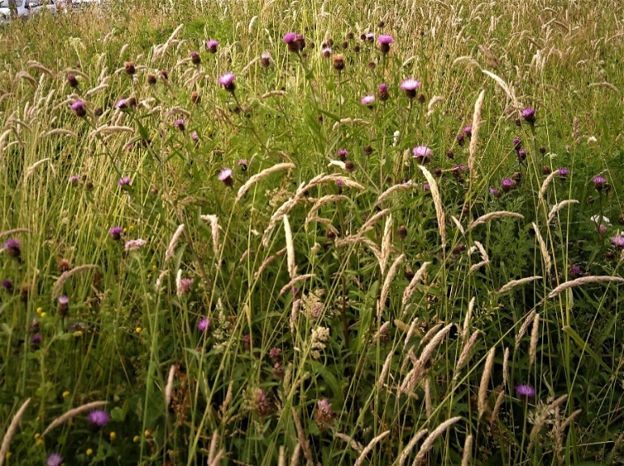

What’s the opposite of a poisoned chalice? Is it pennies from heaven?
I’m spending them now.

I have the task of managing a wildflower meadow, which has somehow dropped into my lap. I’ve always wanted an old-fashioned meadow, full of flowers and insects and grasses in bloom. Normally such meadows are cut for hay, or kept grazed, but this one needs managing by cutting from time to time and I’m doing it in the old way – with a scythe!

Scything is good exercise and incredibly satisfying. It attracts an audience. This particular meadow is not in the countryside but attached to the community centre in my town, which includes the Library, swimming pool, nursery and children’s playground: you know the kind of thing. When scything I always have a little retinue of kids asking me questions and wanting a go. No!

Managing the meadow gives me a chance to watch the annual cycle and notice the emergence of the different species. I see the differences across the patch, who turns up when. There are about forty sorts of native wildflowers, each with its resonant name. It’s poetry, you can chant it
Lady’s Bedstraw, Ragged Robin,
Birdsfoot Trefoil, Ox-eye Daisy,
Sorrel, Mugwort, Yarrow, Teasel,
Dock!
Yes, there are ‘weeds’, like docks, but they all play a part. The dock is host to an amazing beetle, a greeny-golden jewel in the summer sun, with scary-monster babies. There are lots of insects in the meadow.
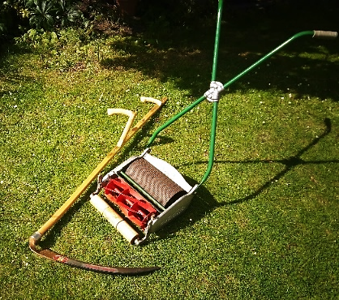

I forgot to mention that the scythe is complemented by a vintage push-mower of a kind you never see these days. For anoraks it’s a Ransomes Ajax Mark V, restored in green and red livery. Purrs along. Heaven!

