THE TRIAL OF DAISY THE COW
Shambala Festival, August 2017

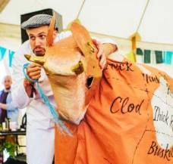
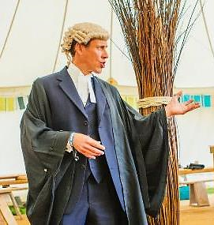
Richard Tutt, Q.C., Defence Counsel. Daisy the Cow and minder Fred Harper

BACKGROUND

Moo!
This event was created as political theatre, to explore the interactions of livestock and the environment.

In recent years it has become increasingly obvious that the global livestock sector has disproportionate impacts on the world environment – on climate change, land use, biodiversity, water supply and pollution by fertilisers. This is one of the reasons why the Shambala Festival has declared itself ‘Meat Free’. But are these impacts fundamental and unavoidable, or are they just the result of the way things are done – which could be changed? Can we actually have sustainable meat?

We wanted to find a dramatic format to explore these questions, and we chose a Crown Court Trial, with a pantomime cow in the dock, representing the global livestock industry and accused of ‘complicity in Ecocide’, that is, grave crimes against the biosphere.

These are of course very serious matters, and we did not want to belittle them. At the same time, we wanted to make the issues accessible and to combine them with humour and classic pantomime-style gags playing on possible prejudices of the audience. A quick example:

JUDGE: This is not a matter of animal welfare. It’s not about nutrition or health or gender or jobs and livelihoods or animal rights. And it is certainly not about vegans! Just to make that very clear, for any of you vegans out there…
DAISY: Moo! Moo!
STOCKMAN: [To cow, Mummerset accent] It’s all right, Daisy.
[To Judge] Sorry sir, it’s just --- the defendant is a vegan…. [Laughter]

DRAMATIS PERSONAE

We populated the occasion will all the usual participants in a Crown Court trial:
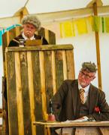
- A judge and the clerk of the court, played by professional actors;
- Two principal advocates, one for the prosecution and one for the defence, played by professional lawyers;
- Expert witnesses, mostly nationally-known authorities plus symbolic stock characters;
- The defendant, a pantomime style cow, operated by two participants;
- A stockman, looking after the defendant; where appropriate answering questions for her;
- Court Bailiff, generally bossing people about, played by a student of stage management;
Judge and Clerk, played by the professional comedy duo, Desperate Men.
- A jury of 12, including a designated foreperson and two other experienced meeting chairs, the rest volunteers from the audience.

SET ETC

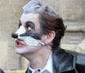
Costumes were fairly basic. Lawyers wore barristers’ wigs and gowns. The judge and clerk wore slightly absurd gowns and wigs. The cow was decorated with principal butcher’s cuts. The stockman wore a stockman’s coat and a flat cap. Some of the witnesses were ‘animals’, a badger, a squirrel and a mole, who wore appropriate animal masks. A further witness represented ‘Grass’ and was dressed in a grass poncho with green makeup. All others wore normal street clothes. The ‘udders’ were simply inflated pink household gloves
Badger mask

Sound effects were minimal. The judge had a gavel and wooden anvil, which he used frequently. The back half of the cow had an amplified app that produced moos, farts and burps as appropriate, and sometimes at random. Generally, proceedings were unamplified, but a hand-held microphone was used by witnesses. A ‘school bell’ was used to signal the beginning of a session.

The venue was a large marquee, and the set was laid out as follows:

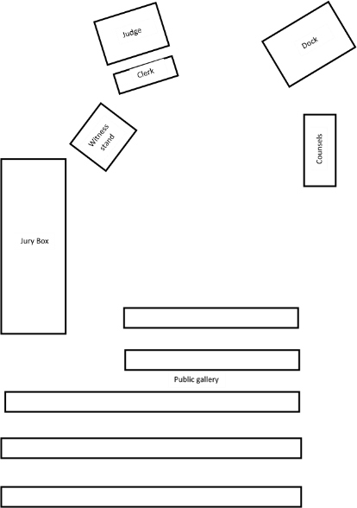
ENTRANCE

THE PROCESS

We planned for an event lasting about two hours. An important aspect was the uncertainty of the outcome. It was felt that the arguments should be carefully balanced, with no scripted verdict.
This caused another problem: the question of Jury sequestration and deliberation. There was not enough time for this to take place in the normal way, but we scheduled a 30 minute coffee break for audience and participants, with the jury allowed to debate during this period, at the end of which they took a secret ballot to generate a verdict.

At first we assumed the whole event could be extemporised, and indeed a great deal was delivered ad lib. But it became obvious that a basic skeleton script was needed to impart structure, and to ensure that all the necessary arguments were heard. It was particularly important that the Counsels should have appropriate briefing questions for the witnesses – as indeed they would have in a real trial. The script was collaboratively developed by Peter Harper, who is professionally involved in the overall theme, and Sarah Woods, a professional playwright. There was no time for rehearsal, but most participants had copies of the script to which they could refer during the event itself, and were expected to extemporise.

Almost any section of the script will illustrate the mixture of serious and informative content with pantomime humour. For example

PROSECUTION: Why are ruminants so special?
DR GARNETT: A large part of the earth’s land is unsuitable for growing crops, but can grow
grass. It’s usually called pasture and is eaten, or grazed, by ruminants. Ruminants can make good use of this pastureland that other animals could not. Non-ruminant animals have to be fed entirely on grain and other crop products, which compete with the better land needed to grow food for people.
PROSECUTION: You make it sound as if ruminants are an ideal form of livestock.
DR GARNETT: Yes, they are rather special.
DAISY moos.
And in some parts of the world there is no alternative. But they also have
drawbacks.
DAISY does a massive fart. The JUDGE looks round.
STOCKMAN: I think she’s got something brewing.
DR GARNETT: The bacterial processes they use to break down grass into digestible food, also generate methane, a very powerful greenhouse gas.
DAISY burps.
This so-called enteric methane is the largest single source of
Greenhouse gases produced by the agricultural sector.
DAISY burps again.
STOCKMAN: She does seem to have very high emissions today, sir.
JUDGE: [Sighs] Do go on, Dr Garnett.

The Proceedings unfolded as follows.

The audience was largely seated as the trial began, with more or less a full house. There had been posters outside the venue with slogans such as “Daisy is Innocent”, “Daisy is a Lying Cow” , “We are all steakholders”, etc.

The Clerk asked all to rise. The judge entered and took his seat, suitably above everybody else. As a comic actor, he quickly established a dyspeptic character with reactionary opinions, incredulous that he should find himself presiding over the trial of a cow. He and the Clerk of the Court (sitting below him) are professional colleagues used to unscripted performance, and were able to insert many moments of off-beat ‘business’.
Ana Kantzelis, Counsel for the Prosecution

The Jury was sworn in collectively and the Counsel for the Prosecution was invited to commence proceedings. She emphasised that the trial was a kind of Class Action against the global livestock industry, not specifically against the defendant herself (Moo!). She then invited an expert witness, Mr Peter Harper, to answer questions about the scope of the Great Livestock Problem. Courtroom drama requires that pompous and high-minded presentations be suitably challenged, even by ad hominem insinuations. In this case, during subsequent cross-examination, the Defence Counsel forced Mr Harper to make a potentially damaging confession:

DEFENCE: Although you claim this is not a strictly vegetarian agenda, would you not agree that your low-livestock vision is easier to contemplate for vegetarians?
MR HARPER: I suppose so.
DEFENCE: Are you in fact a vegetarian yourself?
MR HARPER: As a matter of fact, I am.
DEFENCE: [Eyebrows raised, pause for effect] No further questions.

The next prosecution witness was Dr Tara Garnett, head of the Food Climate Research Network at the University of Oxford, and lead author of a recent report on the global livestock industry. Her evidence suggested the necessity of a drastic reduction in livestock numbers and therefore considerable alterations in dietary patterns. She was particularly concerned to debunk the widespread idea that grass-fed meat has lower impacts than meat from non-grazing stock. This definitely raised the dramatic temperature because it is widely thought that ‘natural’ and especially organic, grass-fed beef is OK, or at least better than ‘feedlot’ beef.
Dr Tara Garnett, expert witness for the Prosecution

Dr Garnett robustly answered the Defence cross-examination. Her evidence was followed by a more knockabout section involving wild animals. A mole burrowed under the Clerk’s table, a Squirrel stole the Judge’s sandwiches, while a cocky and cockney-accented Badger took the witness stand. He argued that their habitats were being destroyed by the excessive space taken up by livestock. From the public gallery there were repeated cries of “More setts for Badgers” which the deaf Judge misheard as “More sex for Badgers” and threatened to have the hecklers arrested for gross indecency.

An even dafter episode involved some inflated pink household gloves used like a glove puppet, suddenly appearing in the witness box:

JUDGE: That brings to an end the case for the prosecution -
PROSECUTION: Your honour, what about the udders?
JUDGE: What others?
PROSECUTION: No your honour – the udders.
The UDDERS take the stand.
JUDGE: (Roars) What?
CLERK The udders, your honour.
JUDGE: The udders?
The UDDERS start to shake with fear.
CLERK: Your honour – I believe this relates to antibiotic resistance which is
threatening the future of the human race, and to the breeding of cows
to have such enormous udders.
DAISY moos mournfully.
FRED: And the mastitis.
An utterly pitiful moo.
JUDGE: This court does not recognise udders as a bona fide witness. Please leave the
stand.
The UDDERS look very sad. DAISY moos.
Udders!
The UDDERS look at the JUDGE.
Please leave the witness stand.
They leave – slowly and very sadly.

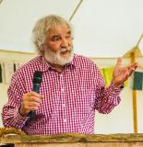
The Defence were then invited to introduce their witnesses, and the first was Colin Tudge, a well-known writer on food topics and instigator of the annual Oxford Real Farming Conferences. Mr Tudge argued that it was not so much the sheer number of farm animals as the way they were managed. He described the attractive alternative of organic, mixed farming systems where crops and livestock were benignly integrated. He was followed by Tom and Debra Willoughby, organic dairy farmers, who argued that a British countryside without cows is unthinkable. Grass-fed beef and dairy products were, they argued, healthier and more natural. Both witnesses argued for a transition from quantity to quality.
Colin Tudge, Expert witness for the Defence

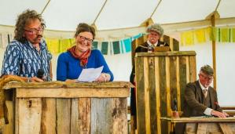
The final witness for the defence was Ms Grass, representing, well, grass. She greatly supported grazing livestock, arguing that grasses and grazers had had a mutually beneficial relationship for at least 50 million years, a compelling argument for the sustainability of grazing. [Approving moos]

The advocates were invited to sum up, and satisfied most expectations regarding this particular moment in a trial with stirring perorations. The court was then adjourned.
Organic dairy farmers Tom and Debra Willoughby, witnesses for the defence, in the witness box. The judge looks on scowling, while the Clerk busies himself with his papers.

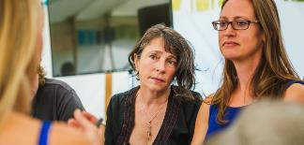
The jury than had half an hour to discuss the arguments they had heard. They took it very seriously, and were given ballot papers to record their personal verdicts. These were collected together by the Foreperson, the only one to know the result in advance.

The court reconvened, and the Judge asked the Foreperson of the Jury whether they had reached a conclusion, remarking that in the circumstances a majority verdict was acceptable. “Do you find the defendant Guilty, or Not Guilty?”. The statutory pause, then
Members of the Jury debating the verdict. The foreperson is in the centre.

“Guilty”!

Moo! On the whole this verdict was a surprise, but was arrived at by an 11-1 majority. Members of the jury later reported that they took a strict interpretation of the ‘class action’ aspect of the case, where Daisy represented the global livestock industry as a whole. Given the evidence as presented, they felt they had no choice but to convict..

The Judge then had to deliver sentence. He said that in view of the good character of the defendant a community sentence was appropriate. He then sentenced Daisy to spend the rest of her life on a City Farm, amusing children.

Daisy was led away, mooing, belching and farting. Catcalls were heard from her disappointed admirers. With a final bang of the gavel, the Court was adjourned.

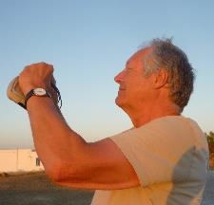
Peter Harper, Producer; Sarah Woods, Director.
Script by Peter Harper and Sarah Woods

THE FUTURE?
After the Shambala event, some wag remarked ‘this show’s got legs’.
Already an ‘academic’ version, using graduate students, is planned for December 2017.
Since Daisy was found Guilty, she could appeal, and the Appeal Court could order a retrial. This is in fact planned for Shambala 2018. With more notice and budget than were possible in 2017, there could be a greater degree of preparation and what might be termed ‘foreplay’ with more banners and demonstrations, and for example, a ‘Daisy, Daisy’ competition featuring such provocations as…

Daisy, Daisy, give me your answer do,
I’m half crazy, oh for the love of you,
I can’t help being a gannet
So two fingers up to the Planet
You’ll look great
Upon the plate
Of a candle-lit dinner for two.

There is further scope for imaginative pedigrees. Daisy’s ancestors are said to include the Cow with the Crumpled Horn and the Bull in the China Shop, while her grandmother is none other than La Vache Qui Rit, from whom perhaps Daisy gets her sense of humour and Europhile political opinions.

WHAT WAS MISSING?
The ‘Trial’ as reported here had one significant drawback: it did not allow airing of possible ‘solutions’ to the livestock sustainability problem. Virtually all expert witnesses on both sides agreed that a general reduction of livestock numbers and meat consumption was highly desirable, both for grazing and non-grazing stock; that the remaining stock should strive for ‘organic’ standards; that there was great scope for technical innovations of many kinds; and that diets with less meat would both improve health and reduce environmental pressures.

Unfortunately in an adversarial trial there is no room for compromise. This problem might be remedied in some formats of the Daisy event, by a general discussion after the Trial proper. This is to be attempted in the version held at CAT in December 2017.

