TRIALS OF AEROBIC ‘COMPOST TEA’
AS A TREATMENT FOR LATE BLIGHT

ABERYSTWYTH EXPERIMENTAL FARM, 2002, 2003

Peter Harper

As part of a general interest in organic pest and disease control, Attention focused on the idea of ‘aerobic compost tea’. This contrasts with most traditional infusions of nutrients or wilted plants, such as manure water or comfrey liquid, which are largely anaerobic. The idea is that the natural take-up of oxygen by bacteria and fungi would be countered by vigorous physical aeration, and (along with various other growth-promoting substances such as seaweed meal and rock flours) could promote the vigorous development of beneficial microbes. Applied to the surfaces of plants, these could potentially prevent pathogen growth by competitive exclusion, or possible other, unknown processes.

The system was vigorously promoting by Dr Elaine Ingham, an American plant pathologist, whose excellent results and presentations at the Soil Association Conference of 2001 persuaded many. I personally met her and found her arguments entirely reasonable.

This process was particularly spoken of in connection with late blight in potatoes (caused by the fungus Phytophthora infestans), the urgency being the then-imminent banning of copper-based fungicides by the Soil Association. Copper-containing ‘Bordeaux Mixture’ had been the only effective ‘organic’ remedy for late blight, but once it was discovered that the copper tended to build up in soils, its unsustainability was obvious and its banning only a matter of time.

As head of research at CAT I was interested to explore this principle, and established a collaboration with Dr Peter Jenkins at the Institute of Biological Sciences (IBS) in the University of Aberystwyth. Dr Jenkins agreed to use a trial field at one of the field stations belonging to IBS. A careful block design was established with four tretaments: control (nothing), Bordeaux Mixture, aerobic compost and anaerobic compost with the same ingredients.

I secured the funding and the equipment, and I prepared the ‘tea’ and delivered it to the experimental site. At the end of the season the different blocks were assessed for incidence of blight, with the result shown in the figure below. Blight lesions are counted in each block to derive a percentage score of blight damage.
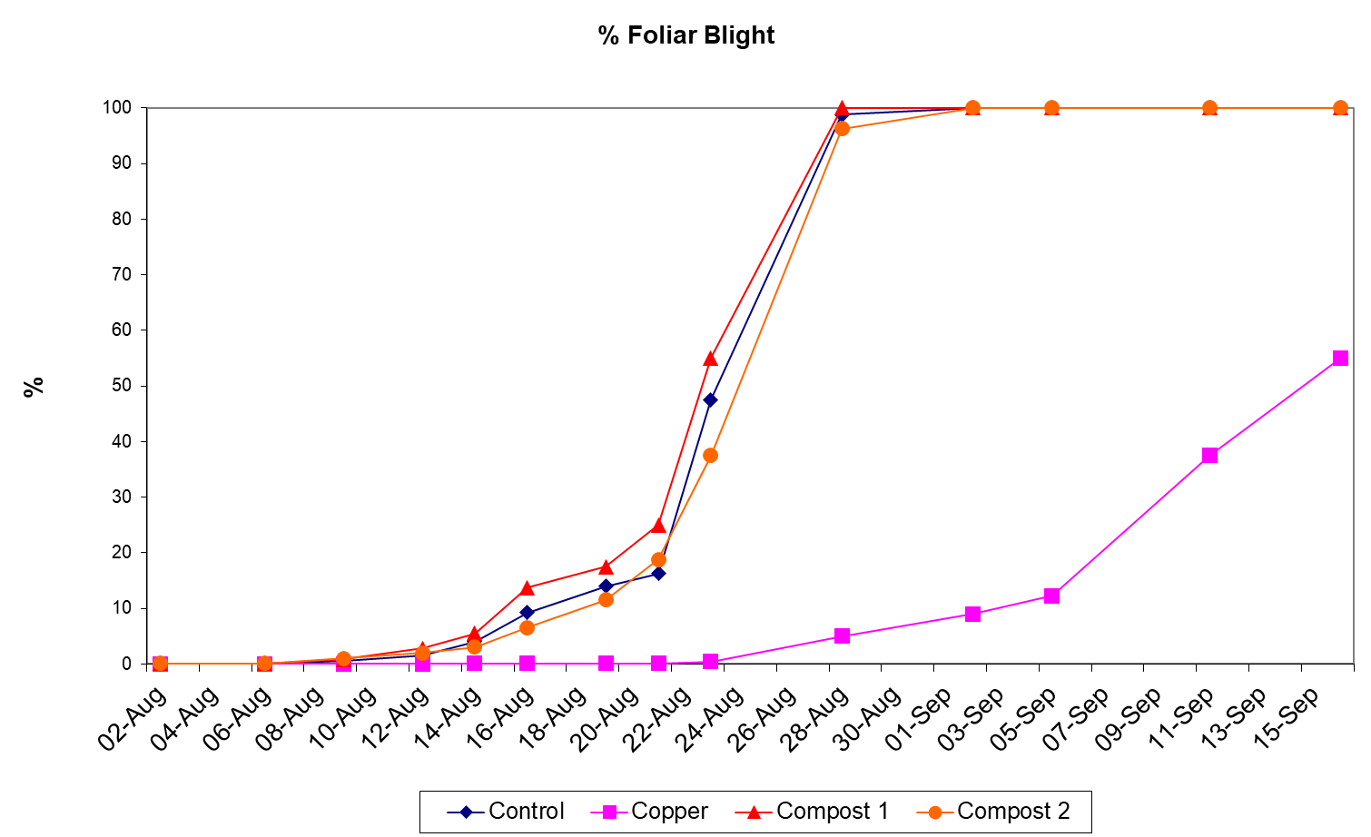

This graph shows the expected effect of copper, but no effect whatever of compost tea, aerobic or otherwise. Naturally this was disappointing, but it was decided to repeat the procedure in the following year. The results were the same.

Here we quite clearly had negative results. Peter Jenkins could possibly have published, but he knew that journal editors are treluctant tyo publish negative results based on somewhat ‘alternative’ notions of plant pathology that most experts would not expect to work anyway. Had we obtained positive results, that would have been a considerable scientific coup. But we didn’t.

Personally, this was a blow, and I assumed it must have been because I made a mistake somewhere and did not follow the protocols precisely enough. However, subsequently I kept running into people who had had the same experience, but not published their results becauser they too assumed they were one-off failures. Further enquiries failed to find anyone who had succeeded, except researchers in the USA.

Experienced potato growers suggested that the syastem might work for light infestations in the dryer USA, but could not deal with typical late blight attack in humid, rainy Britain. Perhaps this is the explanation, but we have to conclude that the system as developed by Dr Ingham fails in the UK.

This specific disappointment however, revealed a much greater problem: that if there is no way to report and collect negative results, we will never learn the truth about ineffective measures.

I wrote to Dr Ingham about our experiences, but she never replied.

The Soil Association showed no interest in our results, or those reported elsewhere.

This suggested that the organic world as a whole is more of cult than an evidence-based movement able to challenge mainstream agriculture on its own ground. Very disappointing.

But the matter goes even deeper, that the editors of peer-reviewed journals are reluctant to publish negative results unless they clearly contradict some widely-held theory.

In retrospect, most of the trials we conducted at CAT were ‘negative’ in that they failed to support certain ‘alternative’ ideas or procedures. Thus, for example, we found no evidence to support the use of rock flours, of the warming effect of black plastic on soil, of ‘Effective Mico-organisms’, ‘flow forms’ or the influence of the moon on plant growth.

In contrast, we did find evidence for the use of urine as a general fertiliser, the addition of paper and card to compost, leeks in non-destructive testing of plant growth and soil fertility, and paper-mill de-inking sludge as a soil amendment.

