BACKGROUND NOTES FOR LECTURES AT SCUMACHER COLLEGE

Peter Harper

LECTURE 1
THE BIG PICTURE

What do we mean by ‘post-carbon? A basic premise of the course is that ‘Dangerous Climate Change’ (DCC) is the key contemporary problem and it is necessary to prevent it. DCC is assumed potentially a very serious issue and justifies early, and possibly disruptive and costly, efforts to prevent it. This is not universally accepted.

The table summarises some of the alternative assumptions that lead to differing attitudes and policy choices. It is well to remember that much discussion about climate issues is a somewhat fuzzy blend of science and politics. In the course, for clarity’s sake we try hard to keep the politics out, but in the end they cannot be ignored.

 |  | CLIMATE MODEL
 |  | LINEAR  No irreversible states | NONLINEAR  Thresholds, irreversibility
POTENTIAL CONSEQUENCES | VERY SERIOUS | Standard national policies  Moderate mitigation measures  Proactive adaptation | “Alarmism”  Strong, early mitigation measures  Adaptation downplayed
 | MINOR OR MODERATE | Climate scepticism  Ad hoc adaptation  Confidence in efficacy of market forces | Later mitigation cheaper Adaptation probably cheaper still  ‘No regrets’ early mitigation

The table is a simple 2X2 matrix. At the top we have a distinction between ‘linear’ and ‘nonlinear’ models of how the climate responds to ‘forcing’, largely by Greenhouse Gases (GHGs). A linear model responds proportionately and predictably; we can see how things go, and if it looks bad we can stop. The problem is tractable and reversible. Nonlinear models include the possibility of threshold, chaotic or abrupt events that lead to irreversible, or even self-deteriorating states that might be effectively insoluble.

Climate scientists, on the whole, tend to favour non-linear models, but as with earthquakes, cannot predict in detail when threshold events might occur. A rather unstable compromise has been reached between the research community and the international political community that temperature rise should not be greater than 2°C: beyond this, non-linear effects are more likely.

This means there is a presumed ‘linear zone’ within which fairly conventional policy measures can be deployed in the hope of slowing warming enough to remain below 2°C, and this is favoured by many governments, including that of the UK. Enlightened official policies are often referred back to the 1986 Brundtland principle of preserving a reasonable intergenerational balance of interests, and the 1992 UNFCCC commitment to avoid ‘dangerous climate change’.

The other dimension is whether the consequences of climate change can be considered ‘serious’. This is a very elastic notion. ‘Serious’ has to be put in a context of unavoidable natural disasters, major wars, epidemics, genocides and so on. If the ultimate consequences of climate change, linear or otherwise, are no worse than this ‘background’, there would be little justification in causing major disruptions to prevent it. Many take this view.

The course is based on the assumptions that climate change is non-linear and potentially very serious indeed. Only this justifies the kinds of measures discussed. It should be borne in mind that this is definitely a minority view, and at odds with much conventional policy. It is good o challenge this apparently extreme position and subject it to rigorous evidential test.

Climate policies tend to fall into two important classes. Some are aimed at preventing, slowing, or ‘mitigating’ climate change; others are aimed at adapting to its effects. The course emphasises mitigation and tends to ignore adaptation, taking the stark view that prevention is better than cure because there is no cure. In contrast, general sentiment and climate policy are shifting towards adaptation, even at the expense of mitigation. The polarisation appears to be deepening.

In the contemporary context, climate change arises principally from emissions of greenhouse gases (GHGs) and although there are other factors in play, broadly GHG emissions (GHGE) can be taken as a proxy for all anthropogenic influences. They are relatively easy to measure, and it is widely agreed that reduction of GHGE to one degree or another is necessary, perhaps even sufficient, to prevent Dangerous Climate Change.

The largest GHG effects, accounting for 60-70% of the whole, are from carbon dioxide derived from burning fossil fuels, mostly for energy. Most attention given to mitigation focuses on ‘decarbonising’ energy systems, and it turns out that in technical terms this is relatively straightforward – although the economic and political issues are much more difficult.

Most of the remaining GHGE arise from food and land use, and here the technical options are far more limited. Actual changes of behaviour, diets and habits would be required for substantial mitigation, and this means the economic and political barriers are even more severe than in the case of energy. For this reason the food/land-use systems are commonly ignored as being hopelessly intractable. This course, in contrast, takes the problem at face value and explores the mitigation options with minimum consideration of social or political factors.

Such an approach might be considered ‘unrealistic’ and in some senses it is. Long experience teaches us however, that as soon as political considerations are allowed into the debate they quickly take over. The approach here is to follow what might be called the ‘Canute Principle’ (after the well-known littoral demarche of the 10th-century Anglo-Danish king), that ultimately the Laws of Nature outrank the Laws of Humanity. The assumption is that better policy emerges from getting the ‘physics’ right and designing political and economic measures later, around the physical requirements, rather than the other way round, which is the normal approach.

Such a brutally ‘physicalist’ approach does simplify matters somewhat. The physical requirements are listed and analysed, and a range of physically compliant ‘solutions’ are worked out. Choices can then be made regarding political and economic likelihoods and preferences.

This must the true for the world as a whole, but it is supposed in some circles that any difficult changes would not apply to the richer part of humanity, which would be able to buy its way out in terms of payments to others. While this is technically possible and perhaps to some extent unavoidable, we make the assumption that each nation would have a requirement to ‘converge’ on common levels of GHGE.

Such a convergence would probably be necessary to secure the necessary international agreements, and in this course we assume that the UK embarks on a rapid decarbonisation programme that embraces all major sources of GHG.

We might refer here to what might be called the Rawls Principle, after the American moral philosopher John Rawls (1921-2002). A paraphrase would be this: you should pick policies as if in ignorance of which part of the global society you happen to be in, or which generation.

At this point we must acknowledge that Climate Change is not the only issue of physical sustainability currently faced by humanity. Rockstrom et al. (2010) attempted to create a complete tally and suggested, in addition to the widely acknowledge 2°C threshold for global warming, eight other potentially ‘planetary boundaries’. These are important for this course, because at least four of them are closely associated with land use and food production.

Ideally we would like to ‘design’, explore, and promote, policy suites that meet all these physical requirements, and it would appear that there are certain policy clusters that do so. In this course we focus on these physically realistic solutions.

Of course we run into immediate cultural, political and economic barriers, and a quick glance might prove extremely discouraging. Sinews need to be stiffened here, and I invoke what we might call the ‘Lampedusa Principle’, after the core idea of the novel The Leopard by Giuseppe di Lampedusa. This idea is that ‘everything must change in order for everything to stay the same’.

There are certain core states and values that we wish to preserve, but it appears that this cannot be done in a Business As Usual, or even mildly reformist, manner. What would be seen as very substantial changes are necessary to prevent DCC, but in a longer perspective these can be seen as relatively modest, planned changes relative to the unplanned changes that would be forced on most parts of most populations if DCC develops in the manner projected by many climate scientists. The conceptual graph summarises the choices and pathways.

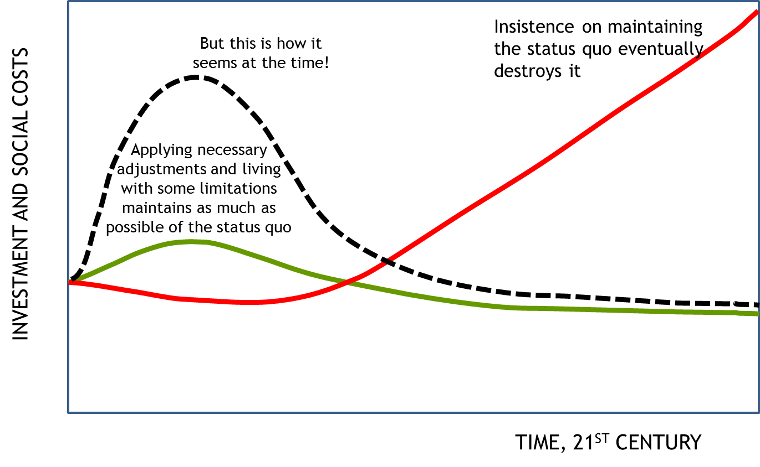
To summarise the above argument: we can see a range of physically-possible solutions to the problems we face at a global scale, and we can see how these might be translated into physically realistic national programmes. We need to concentrate on these and not be distracted by non-physical difficulties. Nature trumps politics, not the other way round.

An outline of the physical requirements is as follows:
- Major reorganisation of energy systems with much lower carbon intensities. Rapid phase-out of fossil fuels.
- Major reorganisation of land use and food systems. Much lower levels of livestock.
- Replanning land use for energy, carbon sequestration and biodiversity.
- Massive research programmes relevant to the above and to geoengineering processes.

LECTURE 2
LOW-CARBON FOOD SYSTEMS

In terms of its effects on GHGE, the food system is different from most other sectors of a modern economy in that its emissions are partly unrelated to energy, and are more difficult to mitigate without changes of customary preferences.

Although this lecture focuses on GHGE, it is worth reminding ourselves at the outset that ‘carbon’ is not the only problem. A sustainable food system for (say) the UK must also provide an adequate and healthy supply, comply with all ‘planetary boundary’ constraints, and do so without prejudice to the needs of other populations. These matters will be dealt with in other lectures.

INSERT
History of food and farming; evolutionary hungers; modern diets

The situation in the world as a whole is too diffuse, so the lecture concentrates on the UK, generalising later to the global level. Very broadly, UK food emissions break down as shown in the pie chart.

The emissions due to imports are substantial, dealt with later. The rest of the chart shows the largest sector as UK agriculture, and we consider this the ‘pre-farm-gate’ collection of emissions, mostly nitrous oxide and methane. After the farm gate, emissions from transport, processing, packaging, storage and consumption amount to almost as much, but are nearly all energy-related, and it is assumed these emissions can be reduced almost to zero by a variety of technical measures described in ZCB3, and largely outside the scope of this course.

The approach adopted to the other emissions categories is a systematic shift of balance from high-emitting to low-emitting foods, and this inevitably entails a change in the pattern of UK diets. The same approach also reduces emissions from imports. The result is shown in the diagram.

This suggests that an overall reduction of 90% is physically possible. The key is in substantial reductions of livestock, and particularly grazing livestock. The logic of this process is summarised in the bar chart: that the output of the livestock sector is notably low, and its emissions notably high

Of course there are enormous political, social and other problems associated with this step, but application of the Lampedusa principle suggests it is actually the most cost-effective measure, and a key that unlocks many other resources. The details are discussed.

Pasta
Rice
Other cereals
White bread
Wholemeal bread
Soft grain (White)
Other bread (Brown)
High fibre breakfast cereals
Other breakfast cereals
Oven baked potato products
Other potatoes dishes
Greenhouse-grown salads
Other UK - grown fresh salads
Seasonal UK vegetables
Imported vegetables
Seasonal UK fruit
Imported fruit
Fruit juice
Whole milk (3.8% fat)
Semi skimmed milk (1.8% fat)
Skimmed milk
Cheddar cheese
Other cheeses
Yoghurt
Fromage frais and dairy based desserts
Non-dairy milk-like products
Eggs
Egg dishes
Beef, veal and dishes
Lamb and dishes
Pork and dishes
Bacon and ham
Sausages
Chicken, turkey and dishes
Coated chicken and turkey
Liver and liver dishes
Burgers and kebabs
Meat pies and pastries
Other meat (game, offal, etc)
White fish including fish fingers
Other white fish and canned tuna
Shellfish
Oily fish
Meat alternatives
Beans and legumes
Nuts and seeds
Biscuits
Buns, cakes, pastries
Puddings
Dairy Ice cream
Cream
Butter
Margarine and other fats and oils
Savoury snacks
Savoury sauces, pickles, condiments
Soups
Fried or roast potatoes
Sugars, and preserves
Sugar confectionery
Chocolate confectionery
Soft drinks
Spirits and liqueurs
Wine
Beer, lager, cider and perry

The lecture discusses the GHGE values of contemporary diets, as opposed to the ‘idealised’ scenario diet. In looking at contemporary food practices it turns out there are ‘packages’ with two principal components. One component is the actual choice of ingredients, and this relates largely to production emissions before the farm gate; the other consists largely of ‘food behaviours’, and this relates mostly to emissions after the farm gate.

Diets in the strict sense of food category choices make a considerable difference to personal and household GHGE. The average UK person’s food generates about 2.4 tonnes CO2e per year. Eating substantially more meat and dairy products can easily push this beyond 3. Eating the same quantity of organic produce does not appear to make a great deal of difference in carbon terms, but this is a contested area.

Eating less meat and dairy lowers the emissions score, but there are many variations. We modelled what we called ‘substitute vegetarianism’ where meat is replaced by an equal quantity of dairy and eggs. This makes a difference, but not a dramatic one. Typical vegans had scores around 1.2 tCO2e, similar to ‘light lacto-vegetarians’.

Behavioural choices can make a considerable difference. Eating 30% more than average (as many do) increases emissions by more or less the same amount; and given that the average person eats too much, emissioins can be reduced simplky by eating less. We found that ‘junk-food’ vegans living off highly-processed foods were not as good as typical vegans. Meanwhile the ‘carbon minimiser’ can get as low as a standard vegan without any ‘taboos’ simply by intensive knowledge of which foods to consume in what quantities.

The lowest plausible case, at around 0.7 tCO2e, was a hypothetical individual we called the ‘best behaviour minimiser’. This idealised person made choices similar to the carbon minimiser, but also ate less, fetched food by walking or bicycle, maximised local produce where effective, prepared most meals from raw ingredients, used efficient appliances, at a lot of raw food, and grew a high proportion of their own fruit and vegetables.

The actual value of ‘good behaviour’ has not been seriously investigated or quantified. Perhaps we can make a start.

LECTURE 3
DIETARY QUALITY AND HEALTH

It is one thing to design diets with low emissions, but can you actually live on them? Are they, in principle at least, healthy diets?

We approached this question in two ways. One was simply to examine various recommendations for dietary health and see if there was broad consistency with the low-low-carbon diets. The other was to subject individual components of various diets to ‘health scores’ and add them up.

Starting with the most general picture, it is obvious that dietary health is an enormously contested area, not least on account of powerful commercial interests, but also government concern for public health, and various ‘ideological’ points of view.

Looking at diets across the world it is clear that an enormous range of possibilities are conmpatible with excellent health, certainly when combined with traditional ways of life. They range from virtually all-meat diets to entirely ‘vegan’. As societies modernise and most people are separated from direct food production, food available for the lower classes is often poor, but improves over the generations. At the same time industrialisation of food does not fully optimise health, and contributes to many of the so-called ‘diseases of civilisation’.

In the past several decades, attempts have been made to devise simple guidelines for healthy eating, and many become the subject of public health campaigns, such as ‘Five a Day’. In general these guidelines are compromises between actual best practice and typical diets, and are designed to ‘nudge’ people in the right direction without ‘frightening the horse’. The full bald truth would probably send many screaming in the opposite direction!

We’ll look at three approaches: Food Pyramids; the notion of ‘balance’ between different kinds of foods; and Nutritional Profiling.

‘Pyramids’ are based on the sensible idea that some foods should be consumed in greater quantity than others, and a pyramidal diagram with layers of equal thickness will reflect this.

The first pyramid system was based on a large volume of epidemiological research by the Harvard School of Public Health in the 1990s. The results came as a substantial challenge to consumers, government and food industry alike. The base of the pyramid (eat lots) was ‘complex carbohydrates’ in contrast to pure sugars and starches, which were relegated to the top layer (eat sparingly). Whole grains and cereals were emphasised, exactly what we had all been moving away from.

The next layer up was fruit and vegetables, and above this the livestock products, plus nuts and other high-protein foods. At the top were fatty and sugary foods (“junk food”), drugs and alcohol.

Subsequently there have been many variations on this theme, and a fairly typical one is shown. Sometimes the vegetables reach the bottom; sometimes the meat reaches the top. Inevitably the results are contested by commercial interests and adjusted by public health bodies trying to find a message that will be both acceptable and effective. But the general consensus is that the basic diet should be built around complex carbohydrates and (ideally fresh) fruit and vegetables, with modest additions of high-protein and high-fat foods, and ‘naughty treats’.

This agrees broadly with the ‘balance idea, that divides a circular plate into segments like a pie chart. A principal example is the ‘eatwell plate’.

You can see that this agrees substantially with the pyramid notion of a diet based around grains and vegatbles, plus livestock products and small quantities of sugary and fatty ‘treats’.

In the UK such ‘plates’ are designed around typical British diets and preferences, and need to be interpreted in this light. Although livestock products are strongly featured, they are not strictly necessary. It would make more sense to reduce the plate to only four segments, as Laura Blake has done in ZCB3. So we have a partition somewhat reminiscent of a CND symbol:

Nutritionists also recommend definite limits on certain kinds of foods, such as a maximum of 70 g a day for red meat. It would not be healthy to eat all your protein section as beef.

One of the problems with the ‘plate’ approach is that the categories overlap. There is lots of protein in some grains and vegetables; oil in many grains; energy in proteins. Could there be an even simpler system? Colin Tudge boiled his recommendations down to nine words:
Plenty of plants, not much meat, and maximum variety.

This could be paraphrased as: base your diet on fruit and vegetables as much as you can, with as wide a variety as you can manage (to include peas and beans, fermented materials such as miso and yeast extract, fungi, seaweeds, nuts and seeds) and eat other ‘wholefoods’ that take your fancy. If you are short of energy, hunger will lead you to eat more grains. With reasonable variety it is almost impossible not to get enough protein: there is plenty in most whole grains. There is also oil in many whole grains. So possibly the pie could be reduced to just two components, 60% vegetables and fruits (say 40 different kinds), and 40% whole grains (say 15 different kinds), but the ‘rule’ would be even simpler: Live on fruit and vegetables, and if you are hungry top up with whole grains. Your search is not for balance, but for variety.

But admittedly this seems a little severe, and stretches the definition of vegetables! A more realistic suggestion would be to allow 10% ‘rich foods’ that would include another dimension of variety:
Pulses and protein extracts like tofu, and pastes like hoummous
Nuts and seeds
Fungi
Seaweed
Fermented materials
Oils and fats
Sugar, refined flours
Alcohol
Tea, coffee, chocolate
…and of course
Meat and dairy products
Eggs
Fish, seafood

Yet another system of assessing food health is Nutrient Profiling. There are all manner of systems, but essentially they allocate a ‘health score’ to individual foods or commodities. The scores can be added up to assess the relative ‘healthiness’ of different diets.

Laura Blake adapted a system based on one developed by the Food Standards Agency, and we have been able to characterise a wide range of diets by mixing and matching different food classes. This allows us to combine GHGE scores with health scores for a range of diets, and plot them as a scattergram in a kind of Carbon/Health space.

Some of these diets have been discussed before in terms of their carbon emissons (vertical axis). Here they are also plotted on the horizontal ‘health’ axis, with poorer diets a left, better diets at right. It is fairly clear that, on the assumptions made, there is a negative correlation between emissions and health: with some exceptions, the lower-carbon diets are also healthier.

Exceptions include the ‘substitute vegetarian’ that essentially consumes as large a quantity of livestock products as the average, but in the form of milk, cheese and eggs. The ‘junk food vegan’, living on not much more than coca-cola and crisps (there are such) can suffer from extremely poor health, for obvious reasons.

All diets were adequate in terms of energy and protein, except one, which we called the ‘gorilla diet’. Essentially this coinsisted of eating nothing but green vegetables, much as wild gorillas do, except that a human cannot eat 10 kg a day, and cannot get enough protein. This diet is therefore not viable and is marked as such.

The fact that the Gorilla diet scored highest on health suggests the limitations of nutrient profiling, and suggests that it should be combined with some measure of variety or ‘balance’ as in the eatwell plate.

This kind of approach also allows us to explore the effects of future technologies, particularly on the energy side. How would the same diets fare if all on-farm energy, energy for fertilisers, and all post-farm-gate emissions were abolished by new energy technologies? The health scores are essentially the same, although they can be nuanced by measures of ‘balance’, also calculated by Laura Blake. The scattergram below shows the results of this analaysis:

LECTURE 4

LAND AND SPACE FOR THE POST-CARBON FOOD SYSTEM

We have established that a well-designed low-livestock diet can be healthy and have very low GHGE. Can it satisfy other constraints? Can it:

Food the UK population reliably?
Be produced largely in the UK?
Comply with the ‘Planetary Boundaries’?
Leave space for other requirements of a comprehensive decarbonisation policy

How much food do we need, and how much land do we need? The question of national self-sufficiency was addressed by Kenneth Mellanby in 1976, and revisited by Simon Fairlie in 2008. Both came to the conclusion that the UK could easily feed itself with a lower proportion of livestock in the agricultural mix – and therefore the diet. This follows simply from the kinds of principles explored by academic ecologists in the 60s and 70s (Odum), that to a fair approximation, there are energy lkosses of 80-90% across each tropiv level. There are many plants, far fewer herbivores (at least in terms of biomass) and far fewer stilol carnivores. Carnivory is a niche occupation, extremely ‘expensive’ in terms of resources, and therefore of land.

In the ZCB series at CAT we went into many of the same calculations and largely confirmed them. We worked from both ends. One study started with agricultural commodities, altered the proportions to minimise GHGE, then checked the land required. It was much less. The study then ran the products forward through the various post-farm-gate systems to the point of sale to ensure there was enough food in terms of calories and protein, which there indeed was.

Another study started with actual foods as consumed, re-designed the average diet for both low GHGE and nutritional value (based on the ‘eatwell plate’), then worked ‘backwards’ through the food chain to the commodities to establish land required. The two studies were in close agreement.

In both cases, GHGE from food production were reduced from around 150 to 20 MtCOe/y, and land from 16.5 million hectares to 8 Mha. Imports were reduced from around 42% to around 20%, and most of these were ‘luxury’ items that could easily be foregone. The upshot is that in this scenario the UK becomes more food-secure, and releases 8.5 Mha for other uses. The allocation on the ground is shown in the pie-chart. Note that livestock still occupy nearly half the food-production area.

INDIRECT LAND USE
It is fairly strighforward to measure land use attributable to various commodities in the UK, and reasonable estmates can be made for direct overseas production. There remains a problem however, in accounting for the effects of changing land-use, particularly the clearing of tropical forests for pasture or oil palms or soyabean production. Such changes release a very large quantity of non-energy stored CO2 and are clearly part of the climate hange problem. Who is responsible for them? The farmers themselves? The country in which they occur? Or the countries that benefit from the products? – because a large proportion of these products are exported, mostly for livestock feed.

Once again the poor livestock get the rap! It has been estimated that the UK is responsible or about 100 MtCO2e a year in indirect land use change emissions, of which about 90% are attributable to the livestock sector. These have not been accounted for in the data already presented. If we add them in, the disparity between the livestock and crop sectors becomes even more grotesque, as the chart shows.

The ZCB scenario reduces this effect to a very small level simply by banning imports of livestock or feeds. UK livestock are fed directly from UK arable and grazing land. UK stock farmers have become very dependent on cheap imported soya meal, but this has not always been so, and there are many alternatives.

OTHER LAND USES

Energy crops:
The ZCB scenario shows how the energy system can be decarbonised and still supply customary energy services. Most of the energy is in the form of electricity from renewable sources, and cannot easily be stored. Inevitably, there is a substantial need for storable fuels, and biomass crops play an important part in providing these fuels. A little over 4 Mha are derdicated to energy crops, mostly as short-trotation coppice and high-yielding perennial grasses.

Sequestration crops:
Within the framework of the scenario it is also thought import for the UK to net off its ‘residual emissions’ by means of ‘negative emission’ processes to deliver a net-zero-emission economy. Calculating how much is required and how it shall be delivered, is somewhat uncertain, but various possibilities have been modelled. It was found that around 50 Mt could be sequestered in situ, using restored peat bogs and reforestation, and this would also have large benefits in terms of biodiversity, amenity and forest products. Higher levels, perhaps up to 80 Mt, could be achieved by much larger planting of high-yielding crops such as miscanthus, along with various engineering processes to sequester the carbon, including incorporation into buildings and products, biochar, and mass sequestration in underground silos.

Given that there is no comprehensive world decarbonisation plan, it is hard to say what is the optimum role for a country like Britain. Should it be net-zero within its own borders? Should it import, or export energy? Or food? Should it reduce its livestock component even further? Should it ‘offshore’ its apparent sequestration obligations? Can it simply pay for international ‘carbon credits’?

These questions are left on the table.

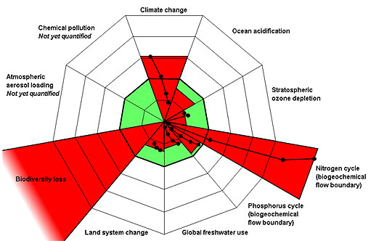
THE OTHER PLANETARY BOUNDARIES
Several more questions remain, notably the ‘planetary boundaries’ first proposed and calibrated by Rockstrom et al (2010). Of the nine (effectively ten) Climate change and Ocean acidification are coupled through CO2 emissions and mostly associated with fossil fuel combustion. Nevertheless, agriculture as a whole probably contributes 20% to climate change, and perhaps 5% to ocean acidifaction.
What about the other boundary issues? The question has been little asked, bt it is fairly obvious that with a single exception they are strongly influenced by agriculture. The table presents some speculative estimates (they are no more than that) of the impact of agricuylture and the proportion contributed by the livestock sector, and an estimate of the reductions achieved by the ZCB scenario.

KEY:
- Negligible influence
+ Some influence
++ Large influence
+++ Dominant influence

BOUNDARY | INFLUENCE OF AGRICULTURE | PROPORTIONAL INFLUENCE OF LIVESTOCK SECTOR | REDUCTION AS RESULT OF ZCBLU PROPOSALS
Climate Change | + | ++ | ↓
Ocean Acidification | + | ++ | ↓
Ozone Depletion | - | - | -
Reactive Nitrogen | +++ | ++ | ↓↓
Reactive Phosphorus | ++ | + | ↓
Freshwater use | ++ | ++ | ↓
Land System Change | +++ | +++ | ↓↓
Biodiversity | +++ | ++ | ↓↓
Aerosol Loading | + | ? | ?
Chemical Pollution | + | ? | ?

Although these are as yet unsupported claims, they are broadly plausible. Once more the livestock sector is revealed as having the largest malign influence, and the ‘improvements’ attributed to the ZCB scenario are largely a result of livestock reductions.

LECTURE 5

HOUSEHOLD AND COMMUNITY FOOD PRODUCTION

The lecture asks, what is the optimum role of householders and local communities to post-carbon food systems and reducing environmental impacts generally?

The logic of the situation is that ‘growing your own’ does not make a great deal of difference in carbon terms unless the diet is radically changed. The simple reason for this is that the items easily produced by householders already have very low carbon-intensities, even if they are ‘commercially’ produced.

Suppose you eat 750 kg a year. Average is 2.45 tCO2e, an average intensity of 3.3kg/kg. Now change your diet so that you eat 50% local seasonal vegetables instead of 6%, and simply reduce everything else pro rata. Seasonal veg are normally rated at 0.8kg/kg, so 345kg ‘emit’ 0.28 tCO2e. Your ‘new’ food emissions would be (2.45-0.28)/2 + 0.28 = 1.37, a substantial reduction of 1.08 or 44%. If you had simply grown your original 6% yourself you would have reduced by 0.04 t or 1.5%. If you grow all your new veggies yourself you would save 0.3 t or 12% relative to buying them.

On the other hand, it is frequently observed that home production of fruit and vegatbles does actually help to shift the diet in a more sustainable direction. One starts to build meals round the seasonal availability of vegetables rather than higher-intensity staples or livestock items, that are often relegated to the role of ‘garnishes’.

As we have already establ;ished, this is a very healthy diet. We must acknowledge however that it is difficult for householders to produce staple grains, oils or meat and dairy produce. Even backyard poultry tends to depend on bought-in feeds. But farmers are very good at producing basic calories and proteins: let them.

In the longer term it is possible to envisage a spatial pattern of food production radiating out from towns and cities, somewhat like that shown in the illustration:

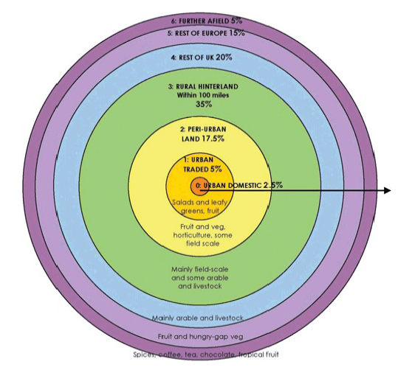
It is obvious that the author of this figure considers most food supply to be commercial, but the “2.5%” of “urban domestic” includes a large majority that cannot or do not want to grow food themselves, leaving much higher proportions for the enthusiasts, who can also take part in the “urban traded” sector, or indeed the peri-urban production of fruit and vegetables and probably livestock as well. The high popularity of City Farms suggests a widespread hunger for more contact with animals, and it is pleasant to imagine that much-expanded small-scale production of eggs, dairy, pork and poultry could take place in the suburbs or peri-urban regions, with much part-time involvement from members of the local community from pensioners to schoolchildren.

OK let us go back to the house-and-garden, accepting that we are not trying for ‘self-sufficiency’ and will play to the strengths of domestic gardens attached to a house and household. There is probably not much point in isolating food from other concerns. We want to design ‘lifestyle packages’ that minimise GHGE while maximising the quality of life. I have sometimes termed this ‘Rationalised Permaculture’ because in the popular conception Permaculture means sustainable living with a large horticultural component, yet the Permaculture movement itself has been reluctant to analyse and quantify the process in order to separate successful and unsuccessful aspects. I have tried to do this.

Look quickly at the breakdown of emissions due to consumption of the average UK person in the average household (although nobody is actually ‘average’ most UK people are close). These are tonnes of CO2e per year
House Energy 2.5
Travel 3.8
Food 2.6
Investment, Goods and Services 4.4
Public services 2.6

These numbers can be moved about a bit within the total. For example is the fridge food or energy? Is a car trip to the supermarket food or transport? But they are broadly defensible. Food is a big chunk but if your aim is to reduce personal emissions you will need to attend to all the categories, and some opportunities will be easier than others. You should of course look for opportunities to ‘synergise’, so that activities in one area will also benefit those in another.

I can present these ideas best in the context of a worked example, based on a ten-year experiment ‘rationalising’ a specific house. The idea was (broadly) to invest savings in improving and modernising the performance of the house, then to carry out various trials of ‘sustainable living’ to compare costs (both in cash and personal difficulties) against benefits in terms of metrics such as energy, carbon, waste etc.

A set of rules was drawn up to guide the process and to assist comparability with other such efforts. The house/garden system were designed together to make use of scrap materials and optimise productivity. Some dietary principles were set up, and the productive parts of the garden gradually brought on stream. Inputs and outputs were measured periodically.

It was important to decide how to allocate space for different garden functions. Recreation, waste treatment, habitat, fruit and vegetable production all have a claim, as do results themselves. In some ways we could regard useful results as the most valuable yield, because they have the potential to improve performance far beyond this particular household.

About 90m2 of land was allocated to fruit and vegetable production in a total area of 210m2. Typical yields displaced about 20% of household food expenditure at organic prices.

One important principle was that no fertilisers or fertilising material should be brought into the system: only naturally arising nutrients should be used. The logic of this is that if most of the food is brought from outside, suitably processed waste should be enough, plus composted grass and garden wastes.

In GHGE terms, the net result of the experiment was as follows, adjusted for actual income and occupancy:
GHGE category | Expected GHGE | Calculated GHGE | % change | Principal measures
House energy | 2.3 | 1.8 | -20 | Low temperature, insulation, heating controls
Travel | 3.6 | 1.9 | -55 | No flying, no car, car club
Food | 3.1 | 0.8 | -74 | Change of diet and food habits.  Possibly 5% directly attributable to home production
Goods and services | 3.1 | 1.8 | -41 | Switch to lower-intensity purchases
Public services | 2.6 | 2.8 | +8 | Below average income
TOTAL | 14.74 | 8.7 | -41

