COMMENTS ON THE PROPOSED EXHIBITION PROJECTS.

Before the exhibition, there were around two dozen separate ideas for exhibits, grouped into functional categories (food, transport etc). Most of these were based on already-existing projects, many of an experimental nature; or on tangible pieces of equipment. The idea was that in each case we’d have something to show, photographs, plans, objects, and possibly results. It did not always work out so neatly, but it is surprising how ‘realistic’ and prescient some of our choices were.

As a broad generalisation, our greatest mistakes were about scale. Lots of the principles are sound, but they only become worth while on a large enough scale, and we had strong bias against mass scale, favouring instead small local communities and households. We assumed that small is always beautiful, but actually it is only sometimes. This mistake is still being made!

Here are the candidates, with comments.

FOOD
- Aquaculture-horticulture rotation system
- Indoor fish-culture unit
- Hydroponics

I have grouped these together because they demonstrate a willingness to accept quite complicated systems, provided they can yield well on a smallish scale. We had a strong belief that ‘self-sufficiency’ – self-provision in food – was not only desirable, but could be readily achieved without too much labour, and on less than a ‘fair allocation’ of land. In the UK of the time we had about 1 acre (0.44 ha) per head, but not all is good growing land, so that suggests systems that a) use less land area and b) are independent of the quality of the land. Hence these intensive “ ’ponics” systems.

The aquaculture systems were based on those pioneered and reported by the New Alchemy Institute in North and Central America. We simply took their word for it. But they never really worked, either for the New Alchemists or in attempts to copy them at the Centre for Alternative Technology in Wales. Later, commercial ‘aquaponics’ systems were more successful in recycling nutrients to optimise growth of both plants and fish, including crustaceans. But as far as I know, it has never been adopted as a community-scale food system, and certainly not at the single-dwelling level, as the New Alchemists attempted to demonstrate in their ‘Ark’ project on Prince Edward Island. It simply failed: the yields were far too low relative to the capital cost and maintenance effort.

Hydroponics (soil-less growing) using cheap mineral fertilisers is much more reliable and is now used at vast commercial scales to produce salad crops. In the early days of AT, the hope was that minerals could be replaced by waste products like wood ash and urine, or fish shit from aquaculture. Well, they can to some extent, but the system is too fiddly and capital-intensive for a household to maintain, and it only produces vegetables, not staples with starch, protein and fats.

Having said this, if you really have to do it and you have the right equipment, it can be done, as witness the Biosphere 2 project in Arizona. Eight ‘Biospherians’ survived for two years on what they could grow on an area of about 300 m² a head, partly using data from the New Alchemy experiments. Remarkable, but dazzlingly expensive.

- Three-dimensional agriculture in New Guinea.
This was derived from the systematic research and quantities measured by the anthropologist Roy Rapoport. To the western eye it does not look like agriculture, but yet it keeps its practitioners fed on a few hours work a day. I think this was one of the inspirations behind Holmgren and Mollison’s notion of ‘Permaculture’ that first emerged around 1978. They noted that in the tropics, western-style plough agriculture usually fails catastrophically, and much subtler, multi-layered plantings work better, using mostly perennial species. This idea has been widely imitated in temperate areas like the UK under the banner of Permaculture, but for the most part has performed poorly. Just as western systems often fail in the tropics, so tropical systems tend to fail elsewhere. In fact, the New Guinea system is not very ‘efficient’ in terms of land, so it does not lend itself to intensive self-sufficiency.

Having said this, the notion of ‘forest gardens’ is now widespread in temperate areas and could encourage dispersed production of tree-crops including high oil- and protein-yielding items such as nuts.

- Soy culture as a source of protein.
This is strangely prescient, because now, many decades later, soya production is big business,and causing substantial deforestation in the tropics. But this is largely used to provide high-protein feed for livestock, not people. The point of the Exhibit was to show that soya beans could be grown in temperate areas, and provide their own nitrogen. They produce meat-equivalent protein on only one tenth of the land used by (say) cattle, so are excellent for intensive production – and are a staple crop.

At the time, a temperate-adapted soybean variety had just been introduced, but it generally performed poorly, and it is almost certainly better to grow ‘genuine’ temperate legumes, of which there are many kinds. They are easily available to householders and are being used as the basis for all manner of high-protein foods and meat substitutes, largely on grounds of low carbon emissions, an issue we were unaware of in 1972.

HOUSING

- Traditional building materials
The rationale given was that these had been displaced by ‘modern’ materials for commercial reasons, which we regarded as distasteful. The displacement is indeed a market effect, because modern materials are much cheaper per unit of service: usually stronger, more durable, easier to apply etc.

Having said this, we can now note that many modern high-performance materials also generate high carbon emissions, while ‘traditional’ materials are much better. As a result there is growing interest in using low-carbon natural materials such as wood and ‘engineered wood’ such as plywood and oriented strand board.

There are also many modern buildings that use low-carbon materials (earth, wood, bamboo, stone, slate, straw, reed) for the bulk of the construction, plus ‘industrial vitamins’ (plastic membranes, steel ties, screws, glass, plumbing and wiring) that bring performance up to modern standards. The WISE Building at CAT in Wales is a good example.

I think many Swedish visitors had been attuned to our strange messages by the publication that year of Gösta Ehrensvärd’s Fore-Efter (Before and After) which painted a picture of how life might be after the collapse of civilisation – widely discussed at the time.

- Non-western house forms
In the febrile 70s there was much criticism of the ‘nuclear family’ and the dwellings produced to house it. If families could be non-nuclear, what patterns might be more suitable? These are reasonable questions, although subsequent experience suggests that the nuclear pattern is the overwhelmingly preferred form in modern societies.

Still, social experimentation continues, for instance in the form of co-housing and ‘ecovillages’, and these have engendered new patterns of physical layout to accommodate multi-generational communities. These remain rational solutions to many modern problems.

The famous ‘autonomous terrace’ shown in Radical Technology (1975) suggested thoroughgoing collectivisation, but had a nuclearized equivalent in the re-purposed double terrace at Spencer Street in the British city of Milton Keynes.

- Industrial waste construction materials
Well of course, who wouldn’t? If source materials are cheap and can be made into something useful, what’s not to like? Unfortunately, waste materials are often in the wrong form, in the wrong place, arising erratically and perhaps contaminated. And they are usually only a small fraction of the total cost, so the industries concerned usually prefer to get clean raw materials whenever they can.

Although the notion of ‘industrial ecology’ became very fashionable, with the Danish city of Kalundborg as its poster-child, in practice it proved much more difficult and never became common practice.

From today’s perspective we relate this question to recycling of household waste, the ‘zero-waste’ movement, and the so-called ‘circular economy’. Great improvements have been made, but they are not driven by plain market forces: they require ‘ideological’ intervention. As perhaps, they did in 1972.

- Autonomous servicing
This was astonishingly fashionable in the early 70s. It fitted our decentralised, self-sufficiency vision. Most of the technical ideas, however, came from a group at the University of Cambridge around the architect Alex Pike, who looked down on us a mere ‘enthusiasts’. This academic group carefully analysed the relative costs of ‘autonomous’ and ‘reticulated’ (i.e. public) servicing and generally found that public provision was much cheaper, used less stuff, and was generally better all round. Subsequent analysis at the Centre for Alternative Technology (somewhat with gritted teeth) confirmed this.

Rolling your own can be very expensive. Robert and Brenda Vale were part of the Cambridge group and carried out a three-year joint-PhD programme exploring self-sufficiency at a smallholding level. Subsequently asked whether self-sufficiency was actually possible, Robert replied, ‘Well, yes, almost – but you need to have a bloody good job to be able to afford all the equipment’.

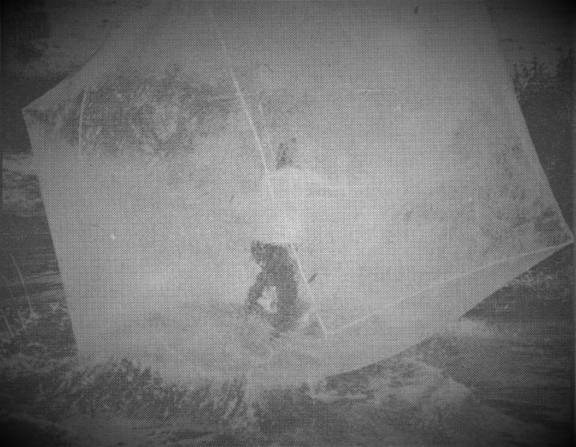
- Inflatables
These were not part of the original plan, but turned up anyway in response to our call for ‘alternative structures’. They were mainly play objects (as many have become in subsequent years) and visitors were invited to step inside zippered inflatables and ‘walk on water’ just a few metres from the Exhibition door.

POWER
- Wind power
- Basic principles of wind energy
- Fixed windmills

I have grouped these together because they were intended to introduce the general idea to Exhibition visitors. Of course, everyone was aware that windmills were used in the past, but it was assumed wind was an old and rather feeble, erratic source of energy and not suitable for a modern economy.
As so often, we got the scales wrong. We really loved the old-style windmills and thought they could be repurposed to produce electricity. Of course they can, but at a ridiculous cost and to little effect, but we hated the idea of large commercially-run industrial-scale turbines. However, at the exhibition we had a lovely foot-high model of the Danish Gedser-type wind turbine, that eventually led to the modern Danish (and thence, world) wind industry. We thought this model was pretty cool, but we didn’t sit down and work out the implications if wind were to be a serious contributor to grid electricity supply.

Now we understand. They’ve got to be aerodynamically designed. They’ve got to be big. And there have to be thousands and thousands of them. But it is happening.

- Unorthodox wind-powered devices
Tree-pump
Flying windmill

These illustrate very well the kind of approach we preferred, and the diagrams on the right show how they might work, or not as the case may be. They were developed by the wind enthusiast David Stabb at the Architecture Association.

The tree pump is based on the idea that a tree has a large surface area and can sway substantially in a gusty wind. You just tie ropes to pulleys and run them to some kind of pumping mechanism that can fill a header tank or small reservoir when the wind blows. It could all be pretty low-tech and made by the local blacksmith.

I don’t know anybody who’s tried this seriously, but it could work. We did test it on trees outside the Exhibition, using a 10-kg spring balance to measure the effect, and this impressed visitors on windy days. We too were impressed when we turned up one morning to find the spring-balance ripped to pieces after a storm!

The Flying windmill is based on the idea of kites, that clearly do fly and demonstrate that the wind is stronger the higher you go. This is quite impractical on a small scale, but has been seriously proposed for multi-megawatt machines a kilometre up, tethered by giant cables. It might yet happen.

- Direct sun power
The rationale for sun-power was the same as wind. Carbon emissions were not an issue, but we believed fossil fuels were limited and would run out, hence the fondness for renewables, which were in principle ‘free’, and therefore (we thought) cheap. We did not grasp the extreme difference in energy density between sun/wind and fossil fuels, and hence the need for very large scales to harvest renewable flows.

We delighted in the simple thermosiphon solar collector. No moving parts. It could be made from readily-available materials in an afternoon, set out in the sun, and behold! Hot water! Well, warm water. It always did something.

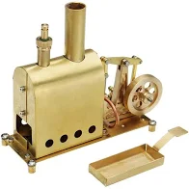
We thought the same principle – passive harvesting of high-energy radiation – could be used to operate an Electrolux-style vapour absorption heat-pump in order to harvest low-temperature heat. And it can, in principle, but experience shows that the efficiency is low, and although there are no ‘moving parts’ it is still a highly sophisticated assemblage of industrial components. It cannot be made by the village blacksmith. Might as well have a compressor and all the best kit. Today? heat pumps are another rapidly developing technology destined for mass take-up.

Perhaps a better idea would be a Stirling Engine operating on solar heat. This does have moving parts, but can operate on just heat rather than a concentrated chemical fuel. Somebody brought along a model Stirling Engine for the Exhibition, and it was regarded as a kind of pet. We thought it was bound be the Engine of the Future, but we are still waiting.

Passive solar heat-pumps were a lemon. But of course solar water-heating became much more sophisticated, industrialised, relatively cheap, and ubiquitous in sunny places. Even more important was solar photovoltaics (PV) still ridiculously expensive in 1972 and somewhat off our radar. But nearly fifty years later, they are now cheaper than coal, deployed on a colossal scale, still improving, and competing with wind to power the world.

- Small-scale water power
This has not changed as much as most other things. The rationale is still the same, and enthusiasts are finding all sorts of little local sources that could power a community. Still, they are marginal in the wider picture.

We thought you could have direct mechanical functions as well as electricity, but that turns out to be silly. Better to generate electricity and use that flexibly for all other functions. Electricity is bound to be the energy lingua-franca for the next hundred years.

- Methane from animal wastes
Well, we tried it at the Exhibition. We had no idea what to do, but we had the idea that AT had to be simple, so we just got on with it. We’d seen the reports from India and China with quite small digestors, using animal dung, so we filled a cylindrical tank with cow manure and waited to see what would happen. Nothing. Well, a small increase in pressure that could be released as a smelly gas.

Now, much more is known about how to digest animal and plant wastes efficiently, and the gas is mainly used to generate electricity for the grid. It is a sophisticated mainstream technology, and part of the suite of systems for backing up the electricity system if supplies from the variable renewables are low.

- Storage of energy
As just remarked, electricity from sun and wind is variable and needs storable back-up. Biomass like animal manure and plant wastes can make methane, or can be thermally converted like fossil fuels. Almost certainly it will be supplemented by hydrogen, which can be generated in times of electricity surplus – which you often get with wind. The Exhibition plan mentions this, but I cannot remember we actually demonstrated electrolysis of water, or that we mentioned anything more about energy storage.

- Flower power
I think this was just a joke.

TRANSPORT

- Methane-powered bus.
Naturally we were against private cars, and envisaged a world dominated by public transport. We knew that you could run vehicles on ‘CNG’ or compressed natural gas, which is of course pure methane, but of course that was a fossil fuel, and we wanted to use biogenic methane.

It never happened, but sustainable transport has moved on, and we now have electric, hydrogen, methanol and bio-propanol powered vehicles. We probably hate cars less, but favour shared systems like car clubs, which we didn’t think of at the time.

- Canals
Here we found the sheer retro-chic irresistible. Canals had been displaced by railways, then roads, and had not moved on. They were beautifully stuck in the early 19th century, and operated with pre-industrial technology. They were consistent with the slower, steady-state world we envisaged. We thought they could be redeveloped to take much more tonnage of freight, and this is probably true, but could never compete with the vast tonnages currently charging around the planet on roads.

A nice try.

- Airships and balloons.
Perhaps these are the aerial equivalent of canals. They recall a bygone age of the slow and steady. Steerable lighter-than-air craft emerge fairly regularly as useful adjuncts to the aviation industry, but never seem to, as it were, take off.

My sense of the process is that they await certain technical developments and a much higher fuel price, perhaps as a result of carbon taxes. If (as seems likely) it will no longer be possible to live on a rapid turnover, ‘just in time’ basis, then they will greatly suit a slower pace of life. They will be back.

MEDICINE
- Malaria control
This might seem an odd item for an Exhibition such as this. It is partly based on the understanding that pesticides could be terminally harmful. In one of the preparatory meetings we had met the Iranian environmentalist M.Taghi Farvar, who had worked with Barry Commoner on DDT in mother’s milk in Guatemala. He had produced a massive tome of cautionary tales entitled The Careless Technology, that convinced us that Nature was easily disturbed by artificial chemicals and other interventions.

We were also seeing the beginnings of a ‘systems approach’ to sustainability, understanding that there could be no simple ‘silver bullet’ solutions, but much more subtle measures based on analysis of the relations between components.

The topic also draws on the obsession with China, where it was thought that, free from the shackles of capitalism and consumerism, they were more able to think, and act, outside the box. We were much taken with the idea of ‘barefoot doctors’ dealing with a wide range of common medical problems, leaving highly-trained specialists to take difficult cases. There seemed to be something romantic about it, like Médicins Sans Frontières. But of course this is simple market forces at work: we now have exactly the equivalent in the form of ‘paramedics’.

- Acupuncture
This also relates to China, and we were confident that the Chinese would not embrace anything that was simply a superstition. It seemed an excellent system because it involved whole-body understanding, without drugs, persuading the body to heal itself by redressing imbalances. Another attraction was that, because the so-called meridians could not be found anatomically, it suggested a radical incompleteness in received western medicine, and indeed western science altogether. It hinted at the possibility of a subtle ‘other world’ beyond materiality that could possibly be the basis of radically alternative way of proceeding.

TEXTILES AND CLOTHING
- Handloom
This was a straightforward ancient technology, entirely transparent in terms of its structure and operation, and we had one on display. For native English speakers, the Swedish name vävstol (‘weave-chair’) was charmingly direct. Of course you can produce real cloth on such a device, and you can make up clothes and wear them, but the time taken is far more than most people would tolerate, and it is not surprising that we now rely on mechanised looms that produce cloth at ten, even a hundred times the rate.

This is of course is true throughout the economy, and productivity is perhaps the principal difference between traditional and modern societies. It was a critical misunderstanding of ours, that we tended to think that mechanised industrial production was only somewhat more productive than the ‘old ways’, perhaps 50% better, perhaps even 100%, but not enough to justify all the downsides. The reality of course is that it is 1000%, even 10,000% more productive: that makes a big difference, and allows us the leisure to play with hand looms if we wish.

It is striking that the celebrated Arts and Crafts movement promoted by William Morris and others praised the production and use of hand-made useful objects, in contrast to the tawdry industrial products of their day. In the Exhibition, we applauded too, without realising that only the wealthy could afford this kind of thing. Today perhaps we appreciate the contribution of the Bauhaus and even IKEA in providing well-functioning, stylish products at reasonable cost.

WASTE DISPOSAL

- Clivus Multrum composting toilet
This is famous in Sweden as a common item in country houses without sewerage connections, invented by the engineer Rikard Lindström. It is very large, and an impressive item in the Exhibition (but not in actual use!). Its attraction for us was that it does not require water, and does not pollute water, but turns a potentially pathogenic waste into valuable fertiliser. It has no moving parts, and operates passively by gravity and small differences in temperature. This was just the kind of self-acting non-industrial alchemy we were looking for.

Composting toilets seemed such a simple no-brainer that we assumed they would soon take over everywhere. This was not be, and they remain on the fringes, although a significant presence in remote fishing clubs, allotments and country parks. People everywhere seem to prefer the ‘porcelain standard’ and are prepared to pay for the network of sewers and treatment plants then required.

Rikard Lindström came to visit during the course of the Exhibition. As he had become a bit of a hero, we were very pleased to meet him.

COMMUNITIES

- Biotechnic housing estate
This was not much more than a student exercise, but it was based on all the latest AT lore and had lovely illustrations. It was more or less a large greenhouse with livestock, hydroponics, solar heating and water-power. It was entirely fantastical but pressed all our buttons and looked gorgeous. Sadly, the drawings are lost, except for a much-reduced sample in Radical Technology.

- Chinese village technology
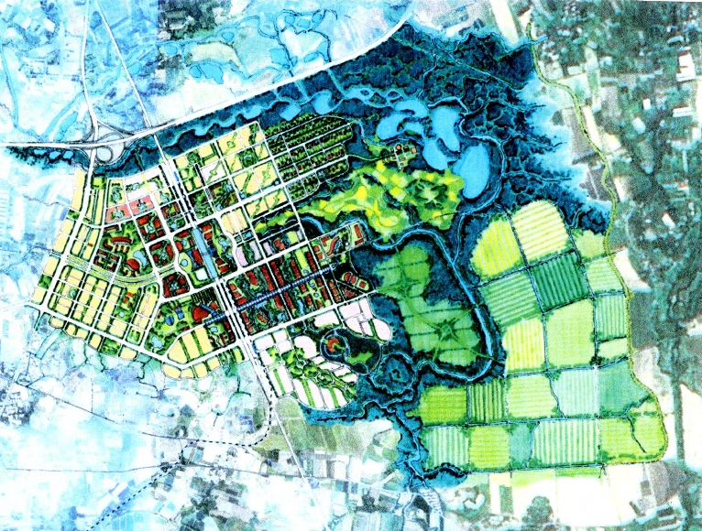
Of course, we knew nothing about China but we were suckers for the propaganda and the traveller’s tales. They seemed to have all the right ideas, relying on local resources in a spirit of mutual self-help. They also had inspiring slogans, many of which we adopted, such as The Taming Power of the Small.

It is my impression that the founders of the Chinese Communist Party, and particularly Mao Zhedong himself, shared many of our pro-rural, anti-consumerist, anti-technological tastes, and that is perhaps why we were so drawn to the stories that emerged. Later of course, China embraced the opposite of all this and it was quite clear which path the people preferred.

Perhaps the most striking visual commentary on Chinese self-reliance was provided by Varis Bokalders, a Swedish architect and planner who contributed a great deal to the Exhibition. In the early 00s he was invited to submit plans for a Chinese town, that would provide enough land to provide food and process waste. Having done the calculations, the allocation of areas was roughly as follows:
Living areas 15%
Food areas 35%
Waste treatment areas 40%

Of course the waste treatment areas (mostly wetlands) also contribute hugely to biodiversity and ecosystem services, but the proportion still come as a surprise.

- Alternative technology research community
This was supposed to combine the full, all-singing, all-dancing alternative dream: communal living, rural life, self-sufficiency, renewable energy, closed-loop recycling, zero-waste, novel uses of traditional materials. It was supposed to record its results and make them known for others to follow – or avoid. An illustration for some of the proposals is shown below.
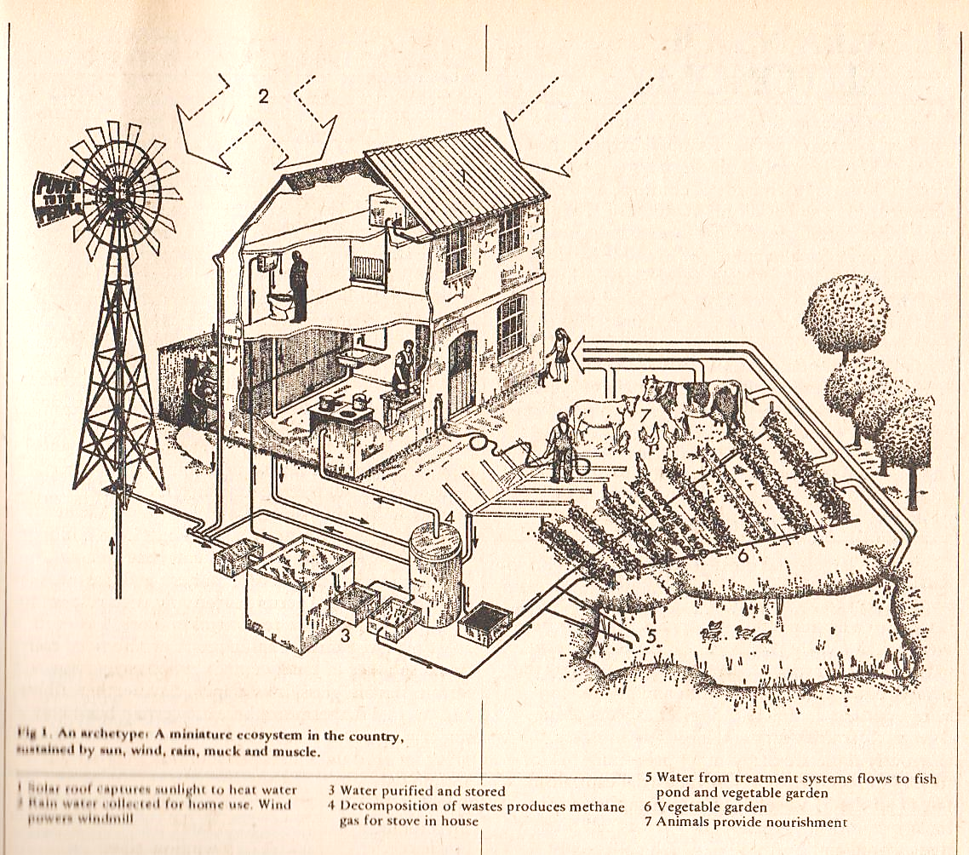

This project did not in the end materialise, but another did: the Centre for Alternative Technology in Wales, founded in 1974 under the influence of the same ideas, which continues to exist 45 years later.

