THE TRIALS OF DAISY THE COW

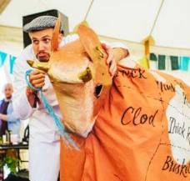
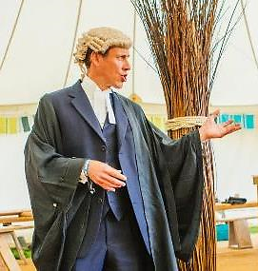
Richard Tutt, QC, Defence Counsel. Daisy the Cow and minder Fred Harper

BACKGROUND
Moo!
This event was originally created in 2017 as political theatre, to explore the interactions of livestock and the environment.

In recent years it has become increasingly obvious that the global livestock sector has disproportionate impacts on the world environment – on climate change, land use, biodiversity, water supply and pollution by fertilisers. But are these impacts fundamental and unavoidable, or are they just the result of the way things are done – which could be changed? Can we actually have sustainable meat – and dairy, eggs, fish etc?

We wanted to find a dramatic format to explore these questions, and we chose a Crown Court Trial, with a pantomime cow in the dock, representing the global livestock industry and accused of ‘complicity in Ecocide’, that is, grave crimes against the biosphere.

These are of course very serious matters, and we did not want to belittle them. At the same time, we wanted to make the issues accessible and to combine them with humour and classic pantomime-style gags playing on possible prejudices of the audience. A quick example:

JUDGE: This is not a matter of animal welfare. It’s not about nutrition or health or gender or jobs and livelihoods or animal rights. And it is certainly not about vegans! Just to make that very clear, for any of you vegans out there…
DAISY: Moo! Moo!
STOCKMAN: [To cow, Mummerset accent] It’s all right, Daisy.
[To Judge] Sorry sir, it’s just --- the defendant is a vegan…. [Laughter]

The first opportunity to stage this event was through an invitation from the Shambala Festival in Northamptonshire in August 2017. Shambala are leaders in sustainability within their sector, and for two years have run an entirely meat-free festival, so an event like this is apropos.

DRAMATIS PERSONAE

We populated the occasion with all the usual participants in a Crown Court trial:
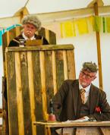
- A judge and the clerk of the court, played by professional actors;
- Two principal advocates, one for the prosecution and one for the defence, played by professional lawyers;
- Expert witnesses, mostly nationally-known authorities plus symbolic stock characters;
- The defendant, a pantomime style cow, operated by two participants;
- A stockman, looking after the defendant; where appropriate answering questions for her;
- Court Bailiff, generally bossing people about, played by a student of stage management;
Judge and Clerk, played by the professional comedy duo, Desperate Men.
- A jury of 12, including a designated foreperson and two other experienced meeting chairs, the rest volunteers from the audience.

SET ETC

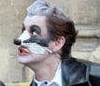
Costumes were fairly basic. Lawyers wore barristers’ wigs and gowns. The judge and clerk wore slightly absurd gowns and wigs. The cow was decorated with principal butcher’s cuts. The stockman wore a stockman’s coat and a flat cap. Some of the witnesses were ‘animals’, a badger, a squirrel and a mole, who wore appropriate animal masks. A further witness represented ‘Grass’ and was dressed in a grass poncho with green makeup. All others wore normal street clothes. The ‘udders’ were simply inflated pink household gloves
Badger mask

Sound effects were minimal. The judge had a gavel and wooden anvil, which he used frequently. The back half of the cow had an amplified app that produced moos, farts and burps as appropriate, and sometimes at random. Generally, proceedings were unamplified, but a hand-held microphone was used by witnesses. A ‘school bell’ was used to signal the beginning of a session.

The venue was a large marquee, and the set was laid out as follows:

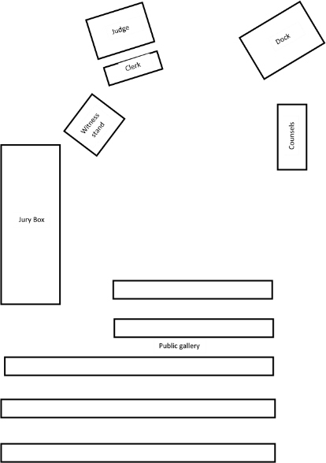
ENTRANCE

THE PROCESS

We planned for an event lasting about two hours. An important aspect was the uncertainty of the outcome. It was felt that the arguments should be carefully balanced, with no scripted verdict.
This caused another problem: the question of Jury sequestration and deliberation. There was not enough time for this to take place in the normal way, but we scheduled a 30-minute coffee break for audience and participants, with the jury allowed to debate during this period, at the end of which they took a secret ballot to generate a verdict.

At first, we assumed the whole event could be extemporised, and indeed a great deal was delivered ad lib. But it became obvious that a basic skeleton script was needed to impart structure, and to ensure that all the necessary arguments were heard. It was particularly important that the Counsels should have appropriate briefing questions for the witnesses – as indeed they would have in a real trial. The script was collaboratively developed by Peter Harper, who is professionally involved in the overall theme, and Sarah Woods, a professional playwright. There was no time for rehearsal, but most participants had copies of the script to which they could refer during the event itself, and were expected to extemporise.

Almost any section of the script will illustrate the mixture of serious and informative content with pantomime humour. For example

PROSECUTION: Why are ruminants so special?
DR GARNETT: A large part of the earth’s land is unsuitable for growing crops, but can grow
grass. It’s usually called pasture and is eaten, or grazed, by ruminants. Ruminants can make good use of this pastureland that other animals could not. Non-ruminant animals have to be fed entirely on grain and other crop products, which compete with the better land needed to grow food for people.
PROSECUTION: You make it sound as if ruminants are an ideal form of livestock.
DR GARNETT: Yes, they are rather special.
DAISY moos.
And in some parts of the world there is no alternative. But they also have
drawbacks.
DAISY does a massive fart. The JUDGE looks round.
STOCKMAN: I think she’s got something brewing.
DR GARNETT: The bacterial processes they use to break down grass into digestible food, also generate methane, a very powerful greenhouse gas.
DAISY burps.
This so-called enteric methane is the largest single source of
Greenhouse gases produced by the agricultural sector.
DAISY burps again.
STOCKMAN: She does seem to have very high emissions today, sir.
JUDGE: [Sighs] Do go on, Dr Garnett.

The Proceedings unfolded as follows.

The audience was largely seated as the trial began, with more or less a full house. There had been posters outside the venue with slogans such as “Daisy is Innocent”, “Daisy is a Lying Cow”, “We are all steakholders”, etc.

The Clerk asked all to rise. The judge entered and took his seat, suitably above everybody else. As a comic actor, he quickly established a dyspeptic character with reactionary opinions, incredulous that he should find himself presiding over the trial of a cow. He and the Clerk of the Court (sitting below him) are professional colleagues used to unscripted performance, and were able to insert many moments of off-beat ‘business’.
Ana Kantzelis, Counsel for the Prosecution

The question of ‘swearing in’ presents opportunities for gags and business. Witnesses can be sworn on tomes other than the Bible, for example Zero-Carbon Britain or some work of Lovelock’s. Alternatively, swearing in can be omitted to save time.

The Jury was sworn in collectively and the Counsel for the Prosecution was invited to commence proceedings. She emphasised that the trial was a kind of Class Action against the global livestock industry, not specifically against the defendant herself (Moo!). She then invited an expert witness, Mr Peter Harper, to answer questions about the scope of the Great Livestock Problem. Courtroom drama requires that pompous and high-minded presentations be suitably challenged, even by ad hominem insinuations. In this case, during subsequent cross-examination, the Defence Counsel forced Mr Harper to make a potentially damaging confession:

DEFENCE: Although you claim this trial is not based on an animal rights agenda, would you not agree that your low-livestock vision is easier to contemplate for vegetarians?
MR HARPER: I suppose so.
DEFENCE: Are you in fact a vegetarian yourself?
MR HARPER: As a matter of fact, I am.
DEFENCE: [Eyebrows raised, pause for effect] No further questions.

The next prosecution witness was Dr Tara Garnett, head of the Food Climate Research Network at the University of Oxford, and lead author of a recent report on the global livestock industry. Her evidence suggested the necessity of a drastic reduction in livestock numbers and therefore considerable alterations in dietary patterns. She was particularly concerned to debunk the widespread idea that grass-fed meat has lower impacts than meat from non-grazing stock. This definitely raised the dramatic temperature because it is widely thought that ‘natural’ and especially organic, grass-fed beef is OK, or at least better than ‘feedlot’ beef.
Dr Tara Garnett, expert witness for the Prosecution

Dr Garnett robustly answered the Defence cross-examination. Her evidence was followed by a more knockabout section involving wild animals. A mole burrowed under the Clerk’s table, a Squirrel stole the Judge’s sandwiches, while a cocky and cockney-accented Badger took the witness stand. He argued that their habitats were being destroyed by the excessive space taken up by livestock. From the public gallery there were repeated cries of “More setts for Badgers” which the deaf Judge misheard as “More sex for Badgers” and threatened to have the hecklers ejected for gross indecency.

An even dafter episode involved some inflated pink household gloves used like a glove puppet, suddenly appearing in the witness box:

JUDGE: That brings to an end the case for the prosecution -
PROSECUTION: Your honour, what about the udders?
JUDGE: What others?
PROSECUTION: No your honour – the udders.
The UDDERS take the stand.
JUDGE: (Roars) What?
CLERK The udders, your honour.
JUDGE: The udders?
The UDDERS start to shake with fear.
CLERK: Your honour – I believe this relates to antibiotic resistance which is
threatening the future of the human race, and to the breeding of cows
to have such enormous udders.
DAISY moos mournfully.
FRED: And the mastitis.
An utterly pitiful moo.
JUDGE: This court does not recognise udders as a bona fide witness. Please leave the
stand.
The UDDERS look very sad. DAISY moos.
Udders!
The UDDERS look at the JUDGE.
Please leave the witness stand.
They leave – slowly and very sadly.

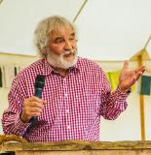
The Defence were then invited to introduce their witnesses, and the first was Colin Tudge, a well-known writer on food topics and instigator of the annual Oxford Real Farming Conferences. Mr Tudge argued that it was not so much the sheer number of farm animals as the way they were managed. He described the attractive alternative of organic, mixed farming systems where crops and livestock were benignly integrated. He was followed by Tom and Debra Willoughby, organic dairy farmers, who argued that a British countryside without cows is unthinkable. Grass-fed beef and dairy products were, they argued, healthier and more natural. Both witnesses argued for a transition from quantity to quality.
Colin Tudge, Expert witness for the Defence

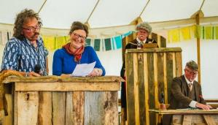
The final witness for the defence was Ms Grass, representing, well, grass. She greatly supported grazing livestock, arguing that grasses and grazers had had a mutually beneficial relationship for at least 50 million years, a compelling argument for the sustainability of grazing. [Approving moos]

The advocates were invited to sum up, and followed convention regarding this particular moment in a trial with stirring perorations. A lovely moment for barristers to strut their stuff. The court was then adjourned.
Organic dairy farmers Tom and Debra Willoughby, witnesses for the defence, in the witness box. The judge looks on scowling, while the Clerk busies himself with his papers.

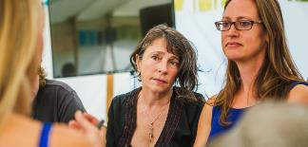
The jury than had half an hour to discuss the arguments they had heard. They took it very seriously, and were given ballot papers to record their personal verdicts. These were collected together by the Foreperson, the only one to know the result in advance.

The court reconvened, and the Judge asked the Foreperson of the Jury whether they had reached a conclusion, remarking that in the circumstances a majority verdict was acceptable. “Do you find the defendant Guilty, or Not Guilty?”. The statutory pause, then
Members of the Jury debating the verdict. The foreperson is in the centre.

“Guilty”!

Moo! On the whole this verdict was a surprise, but was arrived at by an 11-1 majority. Members of the jury later reported that they took a strict interpretation of the ‘class action’ aspect of the case, where Daisy represented the global livestock industry as a whole. Given the evidence as presented, they felt they had no choice but to convict.

The Judge then had to deliver sentence. He said that in view of the good character of the defendant a community sentence was appropriate. He then sentenced Daisy to spend the rest of her life on a City Farm, amusing children.

Daisy was led away, mooing, belching and farting. Catcalls were heard from her disappointed admirers. With a final bang of the gavel, the Court was adjourned.

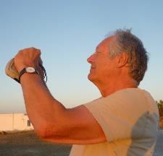
Peter Harper, Producer; Sarah Woods, Director.
Script by Peter Harper and Sarah Woods

COMMENTS
Of course there were many obvious glitches and much room for improvement.

The most significant drawback from a ‘political theatre’ perspective was that a trial is adversarial: it did not allow airing of possible compromise ‘solutions’ to the livestock sustainability problem. Virtually all expert witnesses on both sides agreed that a general reduction of livestock numbers and meat consumption was highly desirable, both for grazing and non-grazing stock; that the remaining stock should strive for ‘organic’ standards; that there was great scope for technical innovations of many kinds; and that diets with less meat would both improve health and reduce environmental pressures.

Unfortunately in an adversarial trial there is no room for compromise. It is very difficult to get a great deal of earnest factual content into the Trial itself without damaging the drama. However, it is possible that a subsequent discussion, in some form or another, could fill in the gaps. Alternatively, the whole audience could be engaged in a general discussion as part of the process of arriving at a verdict.

After the Shambala event, it was remarked that ‘Daisy’s got legs’ (groan). Indeed, a further five versions have now taken place.

THE ‘ACADEMIC’ VERSION OF DECEMBER 2017

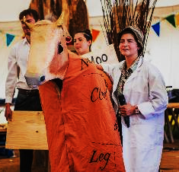
This version of the Trial was intended as a ‘practical’ for students of CAT’s MSc degree in Sustainable Food and Natural Resources. It took place about half way through the course. Preparatory material was circulated beforehand. The students were unaware of the previous Shambala version. They allocated themselves roles and organised the layout of the courtroom; the marshalling of personnel was carried out by a suitably bossy Clerk of the Court. A member of CAT staff took the role of Judge. The event was basically unscripted, although there were suggestions in the form of a ‘Partial Script’.

An unexpected star was a student who took the role of the cow-minder, who, it transpired, had been herself a dairy farmer. Prosecution and Defence were teams of students, one each of which served as the Learned Counsels. Rather surprisingly, the Prosecution team used a holistic and emotional style, with symbolic witnesses such as Ocean, Air and Soil. In contrast, the Defence used much more evidence-based and quantitative arguments.
Sam Allison, the cow-minder at Shambala 2018, who also took the role in the CAT version of 2017.

It is probably fair to say that the quality of witness evidence and argument was weaker than it had been at Shambala, largely because the students had not had time to master the details, and of course at Shambala we had some professional, nationally-recognised witnesses. The hearings lasted 90 minutes, and the Jury was sequestered for one hour to consider its verdict. As at Shambala, the decision was made by secret ballot. When the court reconvened, the Verdict was once again Guilty, and Daisy received the same sentence.

In a semi-scripted nod to the pantomimic aspect of the occasion, the last few moments ran like this:

JUDGE: Daisy the Cow, you have been found guilty of the most egregious crimes against the biosphere. In passing sentence I would like to ask the defence Counsel whether there are any mitigating circumstances.

DEF: [Hamming it up] Your Honour, the defendant was orphaned at a very early age [aaah!] She was subject to continual sexual exploitation, and had all her children forcibly removed, causing great distress [oooh!]. Her diet is strictly controlled, with a vicious cocktail of drugs mixed in in to her feed [tut tut]. She is subject to involuntary euthanasia [oh no!]

JUDGE: There is no need to milk it…. [groans]

DEF: I was going on to say your Honour, that she is a productive and respected member of her peer-group, and from a very good family. I believe her mother was the cow with the crumpled horn, and her father was the Bull in the China Shop….

JUDGE: [Interrupting] Thank you, Mr Stallard, that is quite enough Bull from you [more groans]. However, in view of the defendant’s unfortunate history the Court considers a Community Sentence to be appropriate.
[Portentously] Daisy the Cow, you sentenced to spend the rest of your days amusing children on a City Farm.
[Daisy is led away to start her sentence, mooing mournfully].

After the court was adjourned, the ‘class’ was then able to debate the pros and cons of the case, and to consider possible compromises, such as the ‘default livestock’ principle put forward by Simon Fairlie. Tutors were on hand to guide debate and offer suggestions. Finally, one of the tutors took the floor and pointed out a number of possible misconceptions that had arisen during the proceedings. This, it was assumed, would lead to further debate.

DAISY THE COW: THE RETRIAL.
SHAMBALA FESTIVAL 2018

The 2017 trial, reported above, was considered successful enough to revisit. There was a notion that, having been found Guilty, Daisy could appeal. In turn, the Court of Appeal could order a retrial. This was it, the retrial.
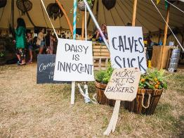
The Trial venue, with campaign placards
This second year, there was more time for preparation. Sarah Woods and Peter Harper put together a more nuanced script, and Sarah and her children (one studying stage management) directed the show and took some key parts. There were more slogans, both on placards and in the mouths of ‘animals’ in the audience, who heckled the court ad lib. There were no professional lawyers, but the Counsel roles were taken by orotund academics. The witnesses were restricted to one ‘serious’ on each side, plus pantomime characters, one of which, the hedgehog, was particularly effective. There was no swearing-in.

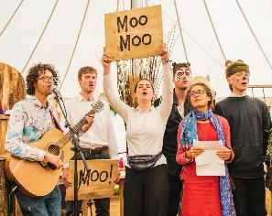
The script was deliberately more adversarial, with the defence witness given the character of a member of the livestock industry, arguing for a high-tech laissez-faire approach. An important improvement on 2017 was a dedicated sound technician delivering high-volume sound effects in the form of moos, belches and farts. There was also an original pantomime song, composed and led by Ben Glasstone, a professional musician. Audience participation was aided by a word-sheet and Moo Moo! Prompts on boards.
Panto song, composed by Ben Glasstone, left. Badger and hedgehog are on the right.

The verdict this time was Not Guilty, and Daisy was released without further ado.

The proceedings were recorded, and a full podcast issued. https://wetransfer.com/downloads/00af3129c1d485ff091fe04e1147c53520180926140538/f7659aafbfbfdcff07345c24981665cc20180926140538/4bb464

It is significant that a further event was held later in the day to debate the motion that the Shambala Festival should (or should not) continue its no-meat policy. Four serious presenters preceded a general discussion, followed by an audience vote by show of hands. Two of the presenters were the main witnesses of the morning’s Retrial: Tara Garnett of the Food Climate Research Network, and Richard Young of the Sustainable Food Trust. They were joined by Simon Fairlie, author of the widely-noted Meat: A Benign Extravagance, and Peter Harper, a principle witness in the 2017 Trial.

This was an important extension of the Trial event, and something that presenters of the project should consider in the future. For the record, the final vote was 3:2 in favour of continuing Shambala’s No Meat policy. Although few regarded ‘no meat at all’ as a likely or feasible future, it was felt that the ‘message’ that you could easily do without meat was a very valuable one and should be maintained.

WORKSHOP VERSION AT CAT MEMBERS’ CONFERENCE 2018

The Centre for Alternative Technology has an annual conference of supporters, who are known as ‘members’. The conference is a mixture of lectures, workshops and demonstrations. On this occasion Peter Harper (a former member of staff at CAT) was invited to run a two-hour workshop working up a short performance for the benefit of delegates.

The workshop was labelled as an exploration of ‘Vulgar Arts’ of the kind suitable to pantomimes. It attracted 12 participants. Peter introduced the basic ideas and invited people to take roles. A draft ‘partial script’ was distributed to impart a basic structure, but it was assumed most would be improvised. There was a certain amount of costume and set material.

Participants took on roles and responsibilities for working up songs, slogans, costumes etc. in the spirit of Vulgar Arts. The ‘court’ was suitably set up with chairs, tables, black cloths etc, and surrounded with campaign posters suggested in an inebriated session round the bar in the evening. For example:

- When all is said and dung, Daisy is INNOCENT
- Scapecows have feelings too
- Veganism is pedigree bull
- A cow less a day keeps climate change away
- Choose the cud
- Hell for Leather
- You Daisy, Me Thane
- Vegans of the world unite! You have nothing to lose but your grains
- Don’t say Cheese

Audience participation was considered an important factor. The roles of animal hecklers were allocated at random to delegates as they came in to ‘watch’ the trial. They were given slips of paper with suitable slogans (again with evidence of alcohol) such as
- More setts for badgers
- More holes for moles
- More hedges for hogs
- More rivers for fish
- More flowers for bees
- More jam for wasps
….and instructed to shout them at appropriate points in the proceedings. Two Brazilian delegates shouted ‘More trees for sloths’ and ‘more burrows for armadilloes’ in Portuguese.

An unscripted moment came when the person who had volunteered to be the back end of the cow failed to turn up, and we had to invite a member of the audience to take the ‘role’. Opportunity of a lifetime!

An important innovation was to treat the entire audience as the Jury. Accordingly, they were given ballot papers. The Trial itself took only 50 minutes. There was no time for debate, but the audience were instructed to write G (Guilty) or NG (Not Guilty) and return their slips for counting. While the count was going on a delegate with a guitar introduced the ‘panto song’ based on the well-known Daisy, Daisy. Verses were composed by workshop participants. The chorus was:
Daisy, Daisy, give me your answer do,
I’m half crazy, oh for the love of you,
I can’t help being a gannet
So two fingers up to the Planet:
You’ll look great
Upon the plate
Of a candle-lit dinner for two

After the song comes the Moment of the Verdict. On this occasion the decision was ‘Guilty’, and Daisy received the same sentence as before: to spend the rest of her years on a city farm.

Daisy lives on, and further versions are planned.

SCRATCH TRIAL AT UNIVERSITY OF BATH, OCTOBER 17, 2018

This was a ‘scratch’ version in that only a few parts were allocated beforehand, and we had to recruit members of the audience to take speaking parts. There was no rehearsal.

It was jointly organised by Caroline Hickman and Peter Harper, using intra-university publicity and dragooning students of various courses, notably The Social Science of Climate Change taught by Dr Aurelie Charles. Props and costumes were assembled beforehand. Our thanks are due to Bath University Student Theatre for the loan of certain costume items, and to Jill Fenwick for making costumes, taking photos, acting as animal prompt, setting up the set and generally glueing the event together.

The event took place in a medium-sized lecture theatre with slightly raked seating, suitable for re-jigging as a court-room. Trestle tables were used for the advocates and on their sides to create a dock for Daisy. Tables with black cloth coverings were used for the judge’s bench and the witness stand, which also had a lectern for scripts.

The sequence of events and timings were written on the classroom whiteboard.
- Quick explanation and introduction 5 minutes
- The Trial 45 minutes
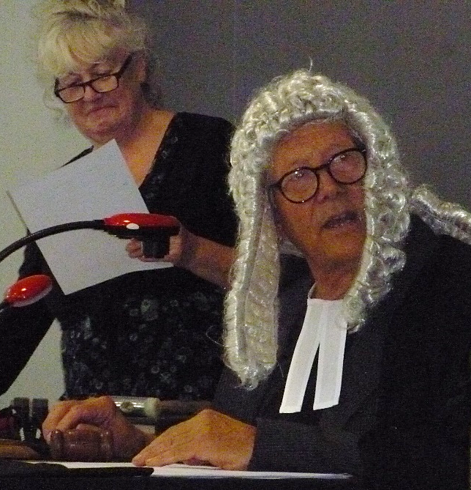
- Debate 30 minutes
- Verdict and sentencing 10 minutes

The roles of Judge and Counsels were pre-allocated. Caroline Hickman took the role of the Clerk, using the lecture theatre console desk, from which she could also operate the sound effects via the AV system. All other roles were allocated to audience volunteers, in some cases lightly pressed.

The sound FX were very ‘effective’ (see/listen to zip file below).

This was a version with a full script that took about 40 minutes to run, condensed from a longer version used at the Shambala Festival in August. There were no microphones, and some role-players, unused to projection to a large audience, spoke rather quietly. They were still audible however. Naturally, there were occasional glitches and pauses as role-players lost their places in the script, but on the whole the drama unfolded quite well, and the audience seemed to follow everything.
Caroline Hickman and Peter Harper in their respective roles as Clerk of the Court/Sound Effects, and Judge

A particular highlight was the appearance of Dr Aurelie Charles as the hedgehog, or Madame L’Herisson, covered in coloured clothes-pegs and arguing with the judge in what sounded like a genuine French accent (her English is so good she ‘ad to ‘am it up a bit). How far we have come from Mrs Tiggy-Winkle! Meanwhile the Barristers offered a contrasting pair, with Cat Fall, a postgraduate student, deploying glamorous sweet reason, while Dr Steve Cayzer created a darkly menacing Defence Attorney. Peter Harper played the dyspeptic pantomime judge.

On this occasion we tried to maximise audience participation by handing out ‘animal heckle’ cards with by-now standard phrases such as “More setts for badgers”, “More hedges for hogs”, “More trees for sloths”, “Save our homes” etc. Those who received these cards were instructed to shout them out when a placard reading ANIMALS was raised. Others received ‘partisan heckle’ prompt sheets with slogans such as “Daisy is Innocent”, “Daisy is a lying cow”, “We are all steakholders”, etc.

On the whole this was unsuccessful. The audience was a highly international collection of undergraduates and appeared to be very shy of making an exhibition of themselves by shouting slogans. As it happened, Caroline Hickman has a large collection of animal glove-puppets, fox, duck, wolf, squirrel and many others. These were also given to members of the audience, and they were quite willing to brandish them at the sign of ANIMALS. This was very amusing, but it would have been even better to hear some loud heckling. Something to consider for the future.

Further audience participation was ensured, as in the recent CAT version, by using the whole audience as the jury. As at CAT they were given cards to write G or NG. An important innovation however, was a 30-minute open debate, chaired by members of university staff who had taken major parts. At the end of this the audience asked to vote and hand in their ballot papers. The ballot papers were then counted and the court reconvened. As usual the Judge asked for the verdict, which (after the statutory dramatic pause) was:
“Guilty!”

This is the fourth Guilty verdict out of five so far, but was very close in terms of ballot votes, only 33:32. It could easily have gone the other way. Incidentally this was a good method of measuring the size of the audience.

General consensus was that this was a successful event, and worth repeating at the university and perhaps elsewhere. It has proved that last-minute allocation of roles can work. The general debate stands in for Jury deliberations, and is possible if there is sufficient time. This element is probably worth maintaining and developing, although it seems to preclude the traditional pantomime song.

What could be changed? Probably the audience need more encouragement to heckle. Perhaps key hecklers (men?) need to be recruited and bound over not to keep the peace. Scratch scripts need to be marked up in advance for each role so that players can see their cues coming up. This is also the case for sound FX and the wielder of the ANIMALS placard.

This performance once again raised the question of who is really in the dock. Daisy ‘represents’ the global livestock industry, yet many might be minded to acquit her on the grounds that she is not personally responsible. Should the judge remind the jury that it is really the industry that is in the dock? If we were really to put some human representative of the industry in the dock, the pantomime aspect of the Trial would collapse, and it would fail in a strictly dramatic sense. But if we keep the cow and remind the jury who she represents, would we then always get a Guilty verdict, because the case against the whole industry is so strong? Part of drama is the uncertainty of the outcome, and the script is written to balance the arguments. Perhaps future scripts re-writes need to bear this in mind.

But for now, Daisy lives to moo another day.

THEATRE VERSION AT THE UNIVERSITY OF BATH, OCTOBER 2019
PROMPTS FOR ANIMAL HECKLES
MORE SETTS FOR BADGERS!

MORE HOLES FOR MOLES!

MORE PONDS FOR DUCKS!

MORE WOODS FOR WEASELS!

MORE JAM FOR WASPS!

MORE GRASS FOR RABBITS!

MORE SAVANNAH FOR LIONS!

MORE BARNS FOR OWLS!

MORE RIVERS FOR EELS!

MORE ROCKS FOR OCTOPI!

MORE BEACHES FOR TURTLES!

MORE OCEANS FOR PUFFER FISH!

MORE CHIPS FOR GULLS!

MORE BAMBOO FOR PANDAS!

MORE TEETH FOR SHARKS!

MORE LAMBS FOR WOLVES!

MORE MOSS FOR REINDEER!

This production tool place in the Weston Studio of The Edge arts complex at the University of Bath. Our thanks are due to BUST, the Bath University Student Theatre, who helped with direction, roles and costumes.

In this version tried to establish all the roles in advance, and to (largely) dispense with scripts. It was partially successful, but many of the roles remained unfilled until the last minute. As always, it is difficult to get busy people to commit time to what is bound to be a marginal part of their lives.

The script was largely rewritten (by Peter Harper) with a view to balancing the arguments on both sides, and principal participants were able to read the script well in advance. Still, nobody really ‘learned their lines’: it just does not seem to be that kind of event.

As with the previous production, the audience constituted the jury, and were asked to return Guilty or Not Guilty votes in a secret ballot. The audience were ‘primed’ with a note on each seat to explain the nature of the event and their role (for the text of this note, see below).

The main trial was completed in 45 minutes, allowing about 15 minutes for discussion with the audience. A rather severe academic introduction seemed to intimidate the audience, but Caroline Hickman (a professional psychotherapist) walked in among the audience and with a gentler and less formal approach soon got everyone talking. This was an important ‘result’.

Caroline also brought along a large number of animal puppets that were given (largely) to children in the audience. A prompt card saying simply ANIMALS triggered the shouting of slogans (see sidebar for suggestions given) and the ‘animals’ produced a terrific racket. This was very effective.

The main failure was the sound effects system. Although there were sound effects it was not possible to control them with appropriate timing. In any future productions it would be important to get the system set up reliably, and with a dedicated operator. The loudspeakers should be close to the cow in the dock.

Sound effects can be extracted from this folder

There was some filming from the BBC World Service at the beginning, so possibly there is some live footage. There were no photographs.

The ‘message to the audience’ is on the next page.

Oh yes…the verdict on this occasion was…
GUILTY!

HELLO, AUDIENCE!!!

You have bravely come to a production of
The Trial of Daisy the Cow.

This is a courtroom drama, but one with an uncertain outcome.
You, the audience, are the jury.
You will have to decide whether Daisy is Guilty, or Not Guilty.

This is how it will unfold. We, the players, will formally Try Daisy, who represents the global livestock industry.
Daisy, representing this industry, is accused of
Complicity in Ecocide; of high crimes against the Biosphere on which we all depend. Listen carefully!

When the trial is adjourned, there will be a discussion. You will have the chance to express your views and quiz the cast. Then there will be a secret ballot, in which each of you will return a folded ballot paper with the word Guilty or the words Not Guilty. The tally of votes will create a Verdict. Is it up to you to decide.

Animals also have a stake in the debate. Some of you will be given animal puppets and a list of demands. When you see the sign saying ANIMALS, repeat the demands as loud as you like, until the Judge shuts you up.

REMEMBER:
YOU ARE ALL PART OF THE SHOW!

