INSECTS AMONG THE FLOWERS
You won’t see many in the winter, but there should be plenty to look out for on a warm summer’s day.

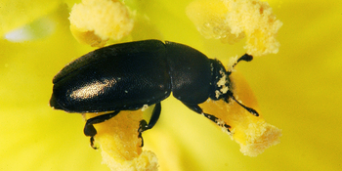
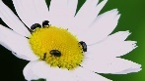
The commonest are pollen beetles. They are small, usually black, and can be seen in the middle of some flowers gorging on pollen. Sometimes they are completely covered in pollen, and look like kids in a ball-pool.

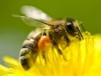
Bees also collect pollen, and they put it into special bags on their back legs. You can see the bags with different pollen colours, depending on the time of year and what they are collecting.

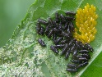

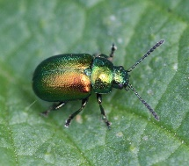
The golden dock beetle is very pretty and lives on docks leaves. It is round and a metallic golden-green. The female lays bright yellow eggs in clumps. Eventually, these hatch out into very vicious-looking black grubs, who proceed to eat the dock leaves to lace. They look mean, but they only eat docks. They won’t try to eat you.

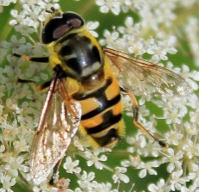
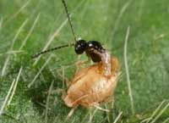
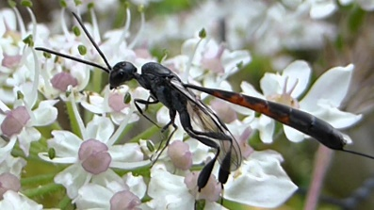
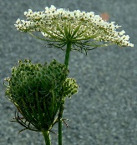
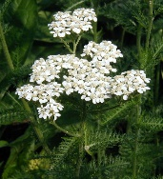
In the later summer you will see two kinds of flowers with flat white tops. One is yarrow, the other wild carrot. Wild carrot usually has a deep red spot in the middle. They both have clusters of very small flowers that attract nectar-feeding insects. As well as bees, you might see hoverflies, which have stripy bottoms like wasps, but hover in one place before diving onto the flower for a feed.

You might also see very small black flying insects that are actually tiny wasps with a strange life-cycle. The adult wasps live on nectar, but they lay their eggs inside other insects. Eventually the eggs hatch out, eat the poor victim from the inside, and turn into adult wasps all inside the host, like a genie in a lamp. Then they cut their way out and become vegetarian again.

