A LOST INTERVIEW WITH IVAN ILLICH
Peter Harper

In the 1970s a book appeared with the title Radical Technology, edited by Godfrey Boyle and myself. It was created by the loose ‘collective’ around the magazine Undercurrents, dedicated to ‘radical science and alternative technology’. The book was systematically organised into eight thematic sections, each with a variety of articles, an illustration by the anarchist artist Cliff Harper, and an interview with a leading practitioner. It is worth saying that Cliff’s illustrations became far better known than the book, and were widely reprinted. The most famous of all was the celebrated ‘autonomous terrace’ shown here.
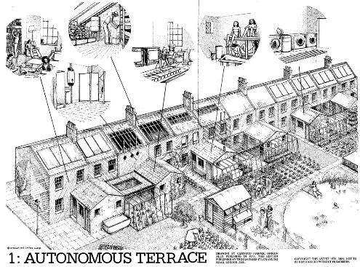

Regarding the interviews, various members of the ‘collective’ undertook to find the relevant gurus and speak to them. My assignment was the famous Austro-Croatian intellectual Ivan Illich, whose critiques of modernity resonated strongly with the neo-primitivism of the time. His major works, De-Schooling Society, Medical Nemesis, Energy and Equity, and (especially) Tools for Conviviality became virtual textbooks of the ‘alternative’ approaches we generally favoured.

I did get to meet and interview Illich, but he would not let me record the interview. What emerged was more an essay on his work, much of which we discussed during our meeting. In the event however, there was too much material to fit into the book, so some things had to go. The curious chivalry of the time ordained that as an editor, the axe should fall on my own interview. It was typeset and ready to go, but was not included in the book. It then became lost, but a photocopy turned up among Godfrey Boyle’s papers following his untimely death in 2019. Here it is, published for the first time.

I have scanned the pages as typeset, and pasted them as images. They are reasonably legible, but the penultimate page has lost the bottom lines. It is probably fair to say it rambles on a bit, and perhaps it is just as well it was not included in Radical Technology. But it will doubtless be of interest to scholars of the period, and anyone interested in the life and work of Ivan Illich, a completely original, indeed uncategorisable, thinker.

Peter Harper

