ECO-EMERGENCY

Captain Mainwaring……………………………………Stephen Peake
Sergeant Wilson………………………………………….Peter Harper

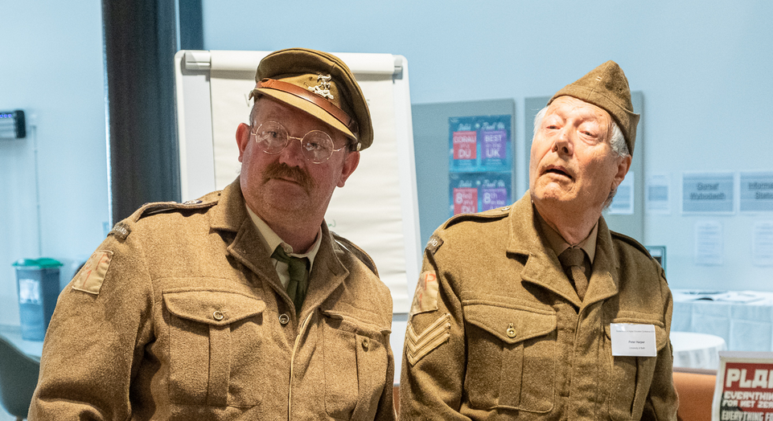

The Dad’s Army theme tune
A table and chair, two flip charts. A hat is on the table.
Manwaring enters

MANWARING:
Wilson! Wilson!

He looks at the audience. It becomes clear that he is looking in a mirror.

He trims his moustache with a pair of scissors and looks at himself from different angles. Finally he picks up the hat and puts it on. It is far too big.

MAINWARING

Wilson!

[Wilson enters carrying his hat]

MAINWARING (CONT)
This is not my hat. Where’s my hat?

WILSON
Here's yours, Sir. We had them all cleaned - it’s been so very hot this summer on parade - for some reason...

[Wilson puts his hat on. This one fits].

MAINWARING
Look here Wilson, I have the detailed plans from the Vice Chancellor
[hands over the sheaf]

WILSON
Really Sir?

MAINWARING
At 0600 hours tomorrow, Ponzi University is declaring a full scale Climate Emergency.

Between you and me, The Vice Chancellor wants to win the Times Higher Ed award for Sustainability Leadership.
She wants us to come up with some radical ideas to show how this university can lead the fight.

WILSON
Yes Sir

MANWARING
Now let’s have a bit of background.
Did you know, Wilson, that this great country leads the world in decarbonisation? Have a look at this.

[Points to chart]. We are here, 45% percent lower than 1990.
And since 2010 we’ve been decarbonising at about two and a half percent a year!

WILSON
It has been argued sir, that this has only been achieved by running down our own industry and relying on others to provide most of our goods. The emissions have not really come down at all, but are simply… happening in other, far away countries…

MAINWARING

…of which we know little, eh Wilson? [Chuckles. Wilson smiles wanly]
Yes, well, that’s their problem.

[Sudden thought, very slowly and deliberately] Or are you suggesting, Wilson, that the British Government is cherry-picking the data,
and trying to pull the wool over our eyes?

WILSON
[Mock horror] Perish the thought sir!

MANWARING
Anyway, the word is that the UK government has now set a new target: of Zero by 2050, and you can’t get lower than that!

WILSON
True enough sir, but [fiddles with notebook and pencil] but I calculate that’s still only 3.2% a year, and the latest IPCC report seems to suggest a required decarbonisation rate of nearer 10 percent a year. So it’s still not quite fast enough.

Do you mind awfully if I just ...

[Wilson points to the flipchart]

MAINWARING
Oh all right then…

WILSON
[Wilson draws a line from 2020 to zero at 2030]

It’s more like this sir.

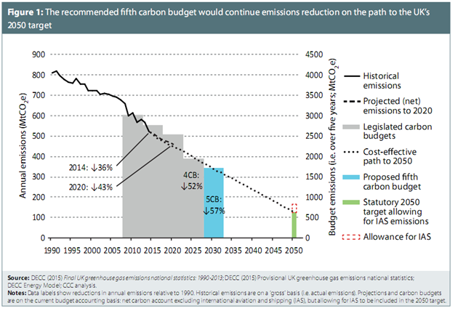
MAINWARING
Exactly Wilson, I was just testing you.

WILSON

Thank you sir. What do you suggest Sir?

MANWARING

We have all the tools to solve the problem right here in the university. We just have to tell everybody.
We are training the next generation to behave in a completely new and sustainable way.

WILSON
That sounds good sir, what did you have in mind?

MAINWARING
Well, look at all these new courses we are about to launch:

[Mainwaring reveals flip-chart page with a list. These are all drawn from the programme of the conference in which the show is staged]:
- Nature and wellbeing
- Global citizenship
- Farmers Markets
- Organisational wellbeing
- Team Teaching
- Bike Sharing
- Art and Science collaboration
- Sustainable Fashion
- Becoming a forest
- Parenting
- Permaculture

WILSON
Permaculture? What on earth’s that sir?

MAINWARING
Can’t say I’m an expert, but you know the kind of thing: [waves hands] forest gardens, companion planting, herb spirals, wild plants, exotic fruit trees, lots of perennials….

WILSON
Doesn’t sound like a lot of calories or proteins Sir: are you sure that’s a viable system?

MAINWARING
Well at least it gives you your Five a Day, keeps you healthy. We’re all supposed to be eating our greens, just like our grandmothers used to tell us to. And we’re consuming too many calories anyway.

WILSON
[Feels his paunch]. You’ve got a point there, Sir

MANWARING
But aren’t these courses absolutely splendid? Just what we need eh, Wilson. What do you think?

WILSON
Awful...

... I mean frightful ...

... I mean awfully, frightfully good.

But - um - well ... the thing is ...

MAINWARING
Spit it out, Wilson

WILSON
Well I can see these could make tremendous contributions to the Quality of Life. It's just that I can’t quite see how these things can decarbonise the wider economy. They don’t have much bearing on industrial processes, steel, cement, transport, heating, electricity, food supply, aviation, hospitals, infrastructure… Surely these are the areas where the emissions are coming from, and perhaps we should take a somewhat more physical approach?

MAINWARING

Like banning drinking straws? Or sourcing all the university’s food from with 50 miles? And then composting all the food waste? And planting more trees on the campus? Or heating the swimming pool with biomass? I know! Serving vegan gooseberry fool in the restaurant! Look, I’ve even got some here; we’ve been meaning to try it out on the students…

[Business offering the stuff to audience, who have biscuit fingers to scoop it up]

WILSON
Well yes Sir, lovely. But even these are rather small, local measures.

MAINWARING
A journey of a thousand miles starts with a single step. Surely, we’d get there in the end?

WILSON
Indeed Sir, but only after several hundred years and we have only ten, maybe twenty. It needs something bigger and faster, a strategic transition involving directed technical development, more like the Apollo Programme, or – surely you remember this Sir – the D-Day Landings.

MAINWARING
[Reminiscing] The D-Day Landings eh? Pity they didn’t give that job to the Home Guard, we’d have shown ‘em!

WILSON
[Rolls his eyes] Quite so Sir.

MANWARING
But dammit man, do the sums! It’s true that each initiative on its own doesn’t sound like much [tapping on his flip chart], but they add up. If we have 50 initiatives each saving 2%, that adds up to 100% decarbonisation: Bingo!

WILSON
Well yes Sir, but if each initiative covers only a tiny part of the economy the net result is still … 2%.

MAINWARING
Don’t be so negative, Wilson. Every little helps.

WILSON
Yes Sir, but only a little.

MAINWARING
Dear, dear, will nothing satisfy you?

WILSON
Sir, I think there have to be changes of a more…er…strategic nature.

MANWARING
Such as?

WILSON
Well sir, I have a short list of examples, would you like to see them?

MANWARING
[Sighs] Get on with it

WILSON
[Turns over flip chart. The list has
- Improve energy efficiency across the economy
- Replace fossil fuels with zero-carbon sources
  - Such as tidal lagoons [a local project in Swansea]
- Strengthen electricity and gas grids
- Research negative-emission processes
- Establish a fiscally neutral carbon tax
- Contribute to carbon diplomacy and international credits
- Maintain nuclear contribution
- Reduce grazing livestock by 80%
- Electrify private transport
- Intensive research into energy storage systems
- Programme of public education to explain the processes
- Education for reskilling at all levels
- Reorientation of the entire research community]

MANWARING
Good God Wilson, isn’t that a bit, well, dirigiste? This sort of thing could bring a government down. And what’s it got to do with the university?

WILSON
You are right Sir, that governments are reluctant to institute measures like these. You need a special sector of the economy that can act as a catalyst. If we really do need to get these processes going very quickly, the universities might be just the place to start. There’s a huge programme of teaching and research crying out to be done.

MANWARING
But how on earth are you going to persuade universities to take this stuff on?

WILSON:
Well Sir, you’d probably need to start from the top.

MANWARING
We’ve been trying to get a massive lagoon off the ground right here!

WILSON
No I mean the top of the university: the VC. It is commonly said that most Vice Chancellors are essentially the CEOs of substantial business enterprises with their eyes glued to the Bottom Line [sniggers in the audience]. They simply don’t like to take risks. Well, not business risks. [More sniggers]. But I think some of them might see the opportunities.

MANWARING
What about the Council, the Senate? Isn’t the VC answerable to them?

WILSON
Indeed Sir, but they are all members of the Great and the Good: they didn’t get where they are by rocking the boat. But you have a point, they’re all retired, got nothing to lose
[distant look]
-- except their grandchildren’s future of course.

MANWARING
What about the staff then?

WILSON
The actual academics sir, well, they are the most conservative of all. They are so overworked, and they have to keep cranking out the papers. [Nods of agreement] No time for the future! Their careers, their mortgages, are at stake!

MANWARING
But surely there are some academics whose professional concern is actually sustainability?

WILSON
Quite so Sir: the sustainability of their own subject. They can carry on indefinitely if they stick to safe topics and don’t rock the boat. Once we start introducing real problems, indeed Wicked problems, it threatens to derail the gravy train. They don’t like it.

MANWARING
Dammit man, there must be some way in.

WILSON
Possibly the students Sir. Thousands of prospective undergraduates are out there on the streets demanding major changes. Why don’t we offer serious undergraduate courses about the rapid and radical changes needed in the next ten years? Every idealistic young student and her dog would be clamouring to get in. No problem with Bums on Seats. The bean-counters would love it.

MANWARING
But to do this we’d have to get the agreement of the staff, the VC and the Council….

WILSON
Bit of a Catch-22 there. Perhaps a clever bit of marketing is needed?

MAINWARING
[Sudden flush of inspiration] But wait Wilson, I can see it. A big transformation. It would need branding. The Ponzi Plan.
Ponzi: The Climate Change University. All teaching, all research, entirely focused on the Great Transition.
[A distant look comes into his eye]

I’m glad I thought of that.

[Curtain]

