PREPARING EDIBLE FOODS FROM ACORNS

Peter Harper October 2018

In a previous document, I recorded the results of a foraging exercise. We could readily acknowledge that foraged plant foods were rich in micro-nutrients, but what about macro-nutrients, carbohydrates, protein and oils? We found that in these respects they yielded very poorly, ten times less than an equivalent weight of a standard food such as flour.

But are there any wild plant foods that deliver high yields of macro-nutrients? Yes, nuts. Nuts are widely cultivated, delicious and ready to eat. But in the wild they tend to be lost to squirrels. I noticed however, that acorns survived on some trees long into the ‘squirrel season’ and were there for the taking.

Acorns have been used historically in Europe as a dietary staple, and have a high quality ‘complete’ protein comparable (they say) to soy protein. But acorns have a high tannin content, so unlike other nuts, they need to be treated before eating. This is tiresome, so they have slipped out of our culinary awareness, although in many respects olives are not much different, and they are hugely popular.

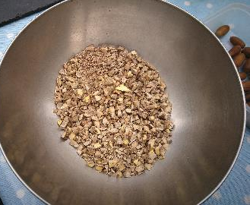
I have been experimenting with acorns. I collected a few kg fresh and green from trees in parkland near where I live in southern England. I removed the outer shells simply by cracking them with a light blow from a planishing hammer (any mallet would do, but something small is best so you can hold the acorn with your fingers and tap lightly on one end).

This is rather tiresome at first but gets faster with practice. There is an inner skin which some US websites have suggested should be removed. I prepared two batches, with and without these skins, and there was no difference, so no need to bother: it’s very fiddly.
Raw acorn grits

You can treat your shelled acorns in several ways. I roughly chopped them up and They looked a bit like ‘crushed nuts’: I thought of the pieces as ‘grits’. Some of these I put into a coffee-grinder to make a flour.

The tannins can be removed simply by soaking in water and changing the water regularly.
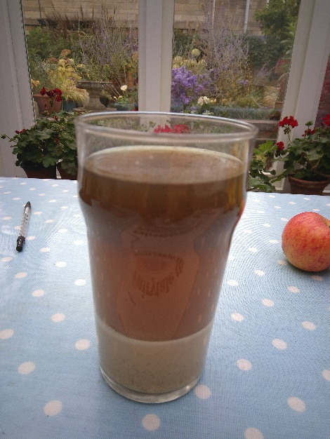
The water quickly becomes brown as the tannins leach out, as you can see from the ‘flour’ soaking in a pint-glass on the right. I changed the water daily and kept this going for five days.

At this stage the grits were not bitter, but tasted like uncooked sweet chestnuts. Then I boiled the grits for about 30 minutes, and decanted the water, which has also become brown, suggesting yet more tannin, although I could not taste it. The grits now had the texture and richness of boiled chestnuts, but not much taste.

You can do several things with these cooked grits. They are like any other kind of nut or cooked legume, comparable with chickpeas or borlotti beans.
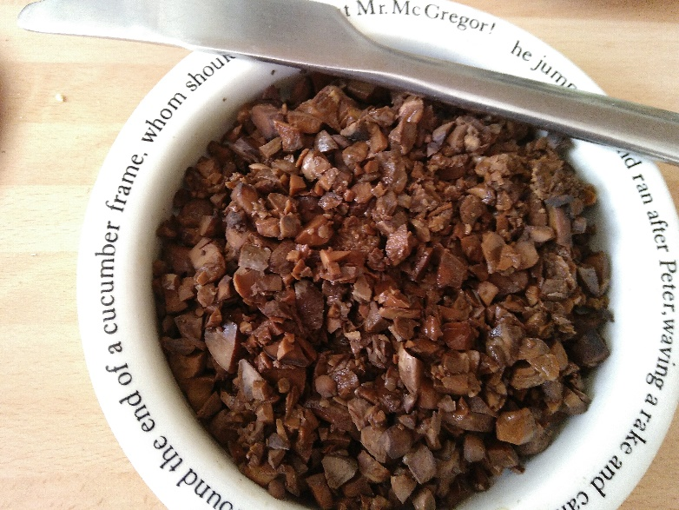
Here is a picture of the cooked grits in a bowl:

Other ‘obvious’ dishes are
- Nut-butter, like peanut butter but with acorns, using a special attachment for an auger juicer;
- Hoummous, combining the grits with garlic, oil, salt and cider-vinegar in a blender. The vinegar is used instead of lemon to demonstrate an all-UK dish. Regular chickpea hummus also includes tahini, another exotic ingredient, but acorn hummus is creamy and does not ‘need’ a rich additive like this.
Cooked acorn grits

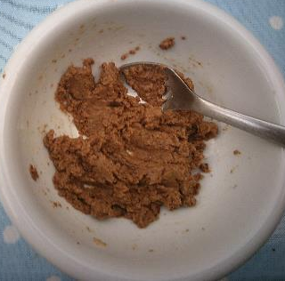
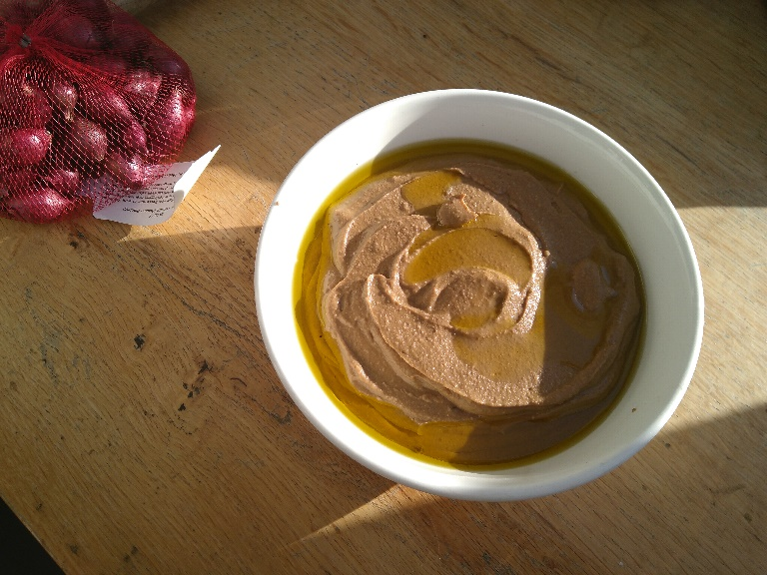
Here are pictures:
Acorn butter
Acorn hoummous

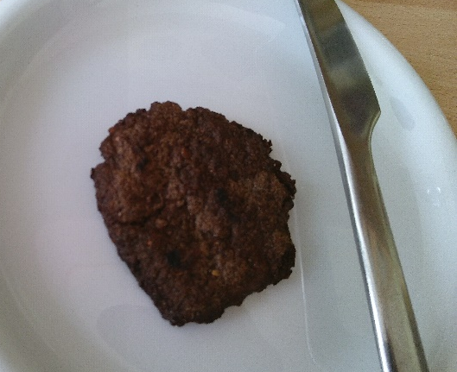
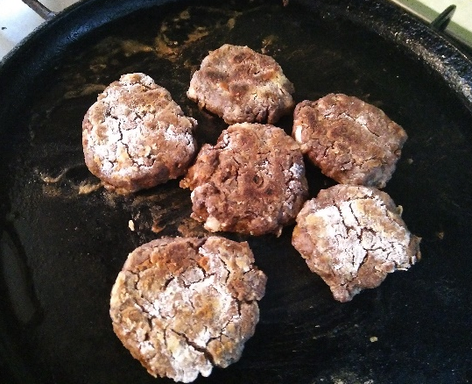
I also made patties/ rissoles using both the grits and the soaked flour, with usual additives such as garlic, oil, salt. They worked fine, but of course much more experimentation is needed to make them irresistible. Some falafel recipes involve uncooked but crushed chickpeas, very similar to the soaked but uncooked grits. I have not tried this yet.
Acorn patties

Acorns can be stored, but I am not sure for how long. My green acorns quickly started to turn brown. After a week they looked like this:

There is no doubt a lost British tradition of collecting, processing and cooking acorns, and it would be nice to see a revival, incorporating everything we have learned from exotic cuisines in recent years.

