PREPARING EDIBLE FOODS FROM ACORNS

Peter Harper October 2018

In a previous document, I recorded the results of a foraging exercise. We could readily acknowledge that foraged plant foods were rich in micro-nutrients, but what about macro-nutrients, carbohydrates, protein and oils? We found that in these respects most foraged plants yielded very poorly, ten times less than an equivalent weight of a standard food such as flour.

But are there any wild plant foods that deliver high yields of macro-nutrients? Yes, nuts. Nuts are widely cultivated, delicious and ready to eat. But in the wild they tend to be lost to squirrels. I noticed however, that acorns survived on some trees long into the ‘squirrel season’ and were there for the taking.

Acorns have been used historically in Europe as a dietary staple, and have a high quality ‘complete’ protein comparable (they say) to soy protein. But acorns have a high tannin content, so unlike other nuts, they need to be treated before eating. This is tiresome, so they have slipped out of our culinary awareness, although in many respects olives are not much different, and they are undoubtedly popular.

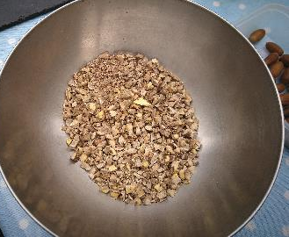
I have been experimenting with acorns. I collected a few kg fresh and green from trees in parkland near where I live in southern England. I removed the outer shells simply by cracking them with a light blow from a planishing hammer (any mallet would do, but something small is best so you can hold the acorn with your fingers and tap lightly on one end).

This is rather tiresome at first but gets faster with practice. There is an inner skin which some US websites have suggested should be removed. I prepared two batches, with and without these skins, and there was no difference, so no need to bother: it’s very fiddly.
Raw acorn grits

You can treat your shelled acorns in several ways. I roughly chopped them up and They looked a bit like ‘crushed nuts’: I thought of the pieces as ‘grits’. Some of these I put into a coffee-grinder to make a flour.

The tannins can be removed simply by soaking in water and changing the water regularly.
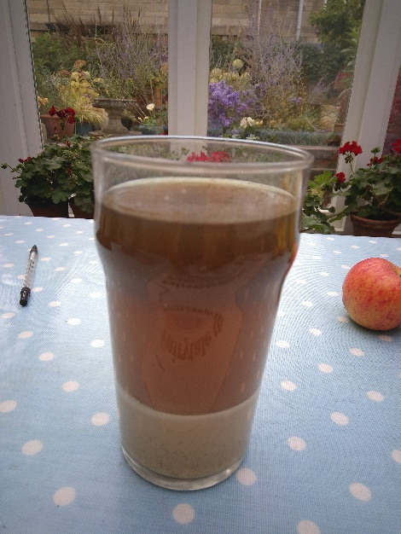
The water quickly becomes brown as the tannins leach out, as you can see from the ‘flour’ soaking in a pint-glass on the right. I changed the water daily and kept this going for five days.

At this stage the grits were not bitter, but tasted like uncooked sweet chestnuts. Then I boiled the grits for about 30 minutes, and decanted the water, which has also become brown, suggesting yet more tannin, although I could not taste it. The grits now had the texture and richness of boiled chestnuts, but not much taste.

You can do several things with these cooked grits. They are like any other kind of nut or cooked legume, comparable with chickpeas or borlotti beans.
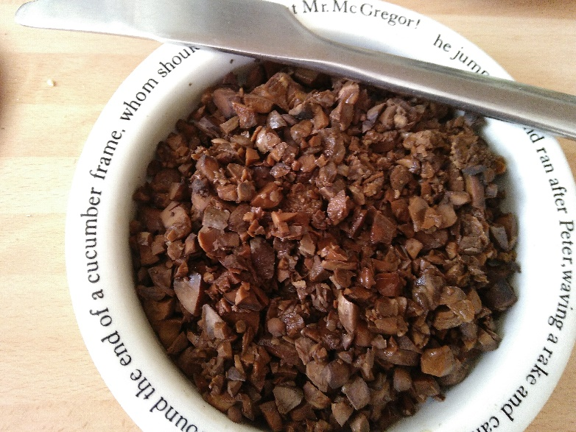
Here is a picture of the cooked grits in a bowl:

Other ‘obvious’ dishes are
- Nut-butter, like peanut butter but with acorns, using a special attachment for an auger juicer;
- Hoummous, combining the grits with garlic, oil, salt and cider-vinegar in a blender. The vinegar is used instead of lemon to demonstrate an all-UK dish. Regular chickpea hummus also includes tahini, another exotic ingredient, but acorn hummus is creamy and does not ‘need’ a rich additive like this.
Cooked acorn grits

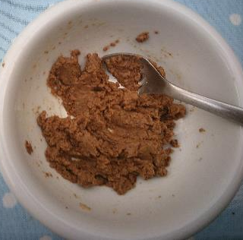
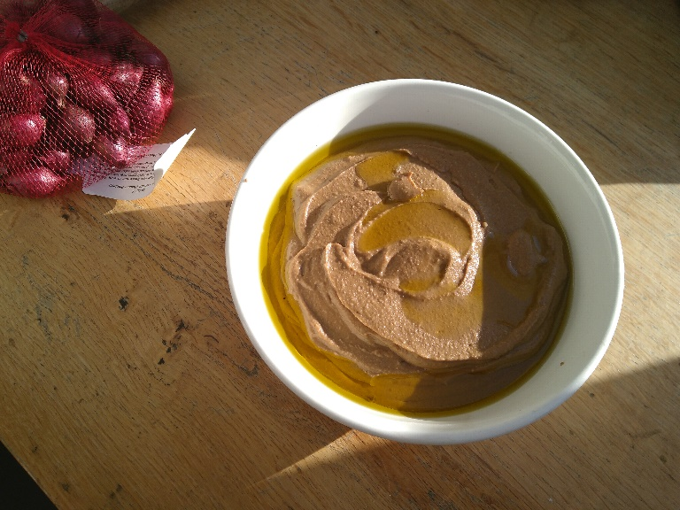
Here are pictures:
Acorn butter
Acorn hoummous

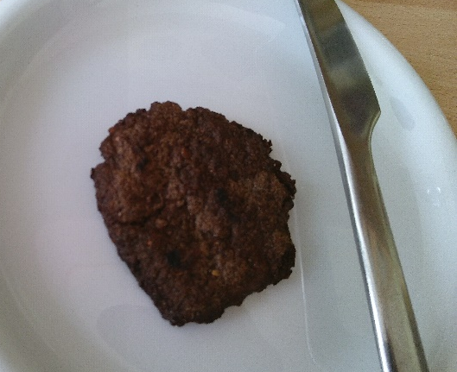
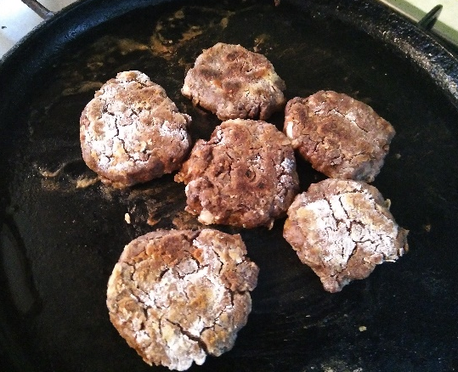
I also made patties/ rissoles using both the grits and the soaked flour, with usual additives such as garlic, oil, salt. They worked fine, but of course much more experimentation is needed to make them irresistible. Some falafel recipes involve uncooked but crushed chickpeas, very similar to the soaked but uncooked grits. I have not tried this yet.
Acorn patties

Acorns can be stored, but I am not sure for how long. My green acorns quickly started to turn brown. After a week they looked like this:

There is no doubt a lost British tradition of collecting, processing and cooking acorns, and it would be nice to see a revival, incorporating everything we have learned from exotic cuisines in recent years.

FURTHER COMMENTS ADDED SEPTEMBER 2022

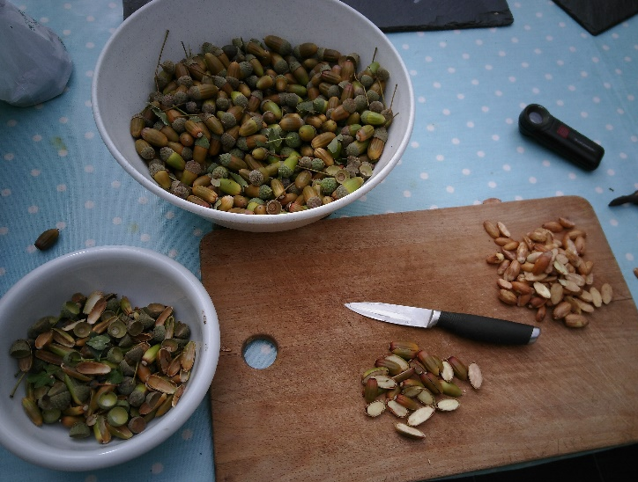
2020 and 2021 were poor years for acorns. In 2020 many acorns were grotesquely deformed and sticky, the apparent result of a gall-insect attacking the acorns. In 2021 there were hardly any acorns at all, and I surmised this might have been a result of the 2020 attacks. I felt rather alarmed. However, 2022 was a bumper year, and might be seen as part of a ‘mast year’ tactic to outwit predators.
Splitting the acorns with a knife. Top, raw acorns, bottom, sliced in two, right, extracted kernels, left shells.

I collected large quantities green in August and September. I extracted the meat simp[ly by cutting the acorns longitudinally in two with a sharp knife, and easing out the kernel halves. Then I chopped them up with a sharp cleaver, or smashed them in a plastic bag, using a rolling pin.

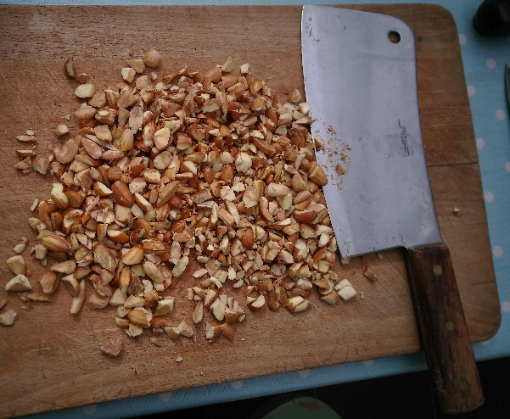
I then boiled them for half hour periods, replacing the water three times. Eventually the supernatant was less dark, and the grits did not taste bitter. This is much faster than simply soaking in cold water.
Coarsely chopped with a cleaver, using a rocking motion

After that the cooked grits can be used for any of the standard purposes above. I put them through a nut-butter maker and they came out as a paste, like say ‘Tartex’ available in tubes. Initially this was brown, but the surface went black, not sure why, but it could be connected to the deepening colour of oak-based inks, see below. It did not look attractive. However ,this paste can be combined with other things and frozen. I had shelled some local hazel nuts and put them also through the butter-maker. They were very oily. I combined the two, and added salt and garlic, yielding ‘acorn and hazelnut hummus’, which could be frozen. I also minced up the cooked grits with flour and onions and bouillon to make small patties or rissoles, then fried the result, yielding ‘acorn bites’. These proved very popular with participants of the mobile story show ‘If Trees Could Speak’.
The brown paste going black on the surface

I have also made rissoles with cooked acorn grits and an equal quantity of basmati rice, plus onion, boullion, gram flour, fresh tomatoes, chopped red pepper and fresh chillies. Very tasty.

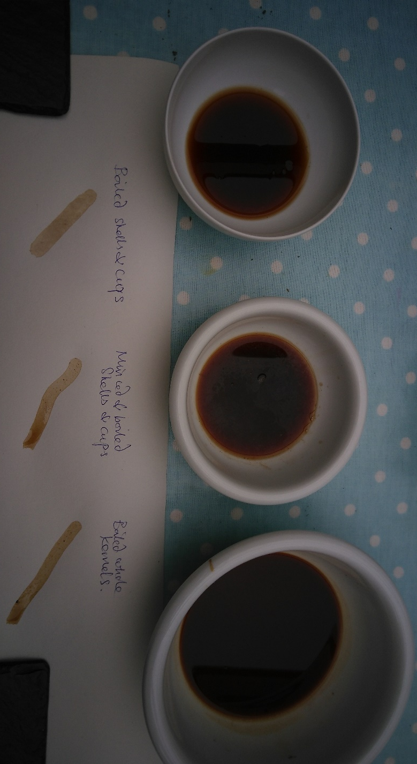
Oak-based inks.
A friend, Chloe Alexander, reported that traditionally, the black ink used in documents such as the Magna Carta and the Declaration of Independence used tannic acid derived from oak galls or ‘oak apples’ combined with iron and gum Arabic.

I could find no oak apples, but I was aware that my acorn kernels produced tannic acid in large quantities, so perhaps any part of the tree does the same. Accordingly, I boiled up acorn shells and acorn cups, and predictably they produced the same dark brown liquors, shown in the photo here.

To this was added a small amount of ferrous sulphate (FeSO₄) and about 20% by volume gum arabic, obtained from an art materials supplier. The liquid became jet black, or rather very dark blue, reminding me of the blue stains you often get when chopping green oak.
This blue-black liquid and could be used for writing with a steel nib, as in the sample below. I failed to cut a feather quill appropriately. There is apparently a great art in doing this.

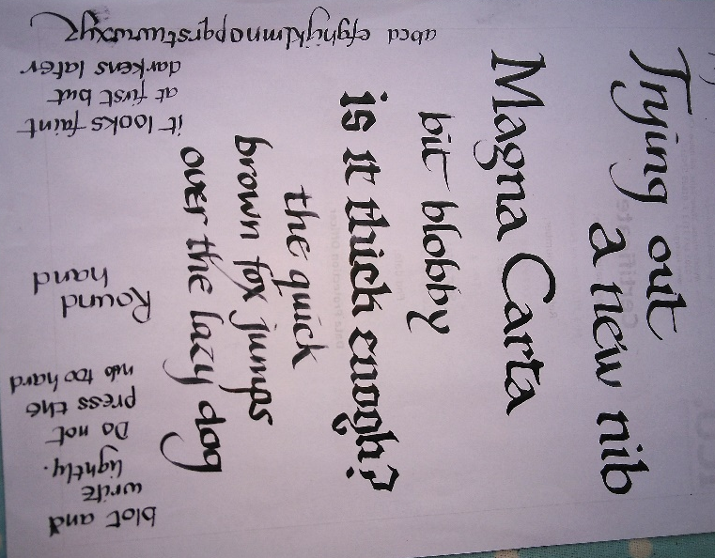
The initial script was fairly weak but intensified on drying. It is hard to say whether it would have been better to use ‘real oak apples’ but this seemed to be good enough. The ink is traditionally known as ‘gall ink’ so the question arises, why were galls themselves used and not the other parts of the tree? One reason might be that were no use for food, either for humans or pigs, and were perhaps sought by small children sent out to collect them. Of course, they might give better results (a denser ink). But I could not find any.

I also made some brown ‘sepia’ ink from the raw integuments of walnuts. I chopped up a handful and boiled it, again yielding a brown liquor. This is said to have been used by Leonardo da Vinci for his drawings, but it’s possible he used squid ink, hence the colour name sepia, the Latin/Greek name for the cuttlefish.

