THE FURTHER ADVENTURES OF THE PEAS

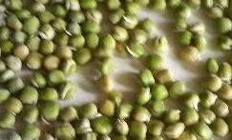
In the January module we weighed dried marrowfat peas and soaked them. 24 hours later they had doubled in weight, but we did not have the equipment to cook them. I took them home and kept them wet for sprouting in a temperature of about 18°C. Remember these are live seeds. By Day 3 there were signs of germination, and by Day 5 you could distinguish the root and the shoot.
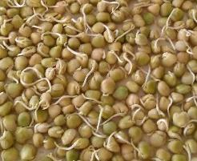
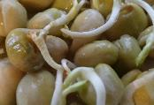
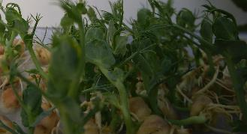
By Day 7 the shoots were turning green and some were transferred to a sheet of kitchen paper to help the roots absorb water. They were placed in a cold conservatory with plenty of light but an average temperature about 5°C, so thereafter went very slowly. But by Day 20 you could see the shapes of the leaves and the characteristic tendrils of vining peas. You can cut these shoots off and cook them. Nice in stir-fries.

SEEDS
Seeds have been around for about 300 million years. The idea is to have a miniature plant (‘embryo’) ready to go, tightly-packed inside a protective coat. The seed is dry and ‘dormant’ until it gets some water and warmth. Then the embryo wakes up and has to make sure it’s got what it needs to grow. It needs energy, and has got some basic rations to be getting on with (peas are a good example: we eat the rations) but these won’t last long. So, it must get its first leaves out to start making chemical energy out of sunlight. The leaves are carried on the shoot, and grow upwards towards the light. The plant also needs water, but this is downwards, so it needs a separate collector, the root, that quickly produces branches to expand the collection area. So, in all germinating seeds you’ll see two elements emerging, one of which bears an initial set of photosynthetic collectors. Photosynthesis uses a pigment called chlorophyll which is green, so you quickly see a green colour in the shoots. This is what has happened to our peas, as you can see in the adjacent photo.

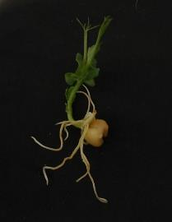

COOKING ENERGY FOR THE PEAS

If you buy food in the shops, some is ready to eat, some is basically prepared and just needs heating up, some is raw or needs preparing or cooking. If we are trying to compare the carbon intensity of different kinds of foods and diets we really need to ask: how much CO2e has been emitted to get it to the plate? For most ready-to-eat foods the cooking and other processing has already been done. In contrast the much-vaunted wholefood diets pride themselves on acquiring raw or minimally-processed ingredients and cooking them at home. Is this likely to have lower GHGE?

Dried peas need cooking, and this needs energy. I was able to get some measurements with an electric pressure-cooker and a special recording plug that tells me the instantaneous power being drawn (in Watts), and the total energy consumed at the end of a process (in Watt-hours).

Rather than use the classroom peas I took 300 g of new dried marrowfat peas and soaked them for 48 hours – more than we did at CAT. The peas continued to soak up water and reached a wet weight of 650 g. This is significant because extra soaking reduces cooking time and takes no energy at all.

I then placed the peas in an electric pressure-cooker surrounded by an insulating bag. I boiled 500 g of water, which required 20 Wh, added it to peas in the cooker, then sealed the cooker and set the time for 20 minutes. The whole process took 30 minutes as it took 10 minutes for the cooker to come up to pressure. At the end the peas were fully cooked, and the energy total was 110 Wh, to which we must add the initial 20 Wh for boiling the water. So total 130 Wh. How can we extract an intensity from this number?

In my specific circumstances much of the electricity would have come from the PVs on the roof, but it would be fairer to use the average intensity of the grid, which is currently 336 gCO2e/kWh. That means the whole process generated 43.7 g CO2. Then it starts to get tricky because we have to decide whether it’s ‘per kg of soaked peas’ or ‘per kg of dried peas’. For the first the answer is 0.067 kg/kg, for the second it’s 0.146 kg/kg.

This is a problem that crops up all the time in ‘Life-Cycle Analysis’ when we are looking at a product ‘from cradle to grave’ as they like to say. The problem is usually stated as ‘what is the functional unit?’ (In mathematical terminology, it is the denominator to the emissions numerator). We need to be able to say ‘emissions per….what?’ Per kg as served, per kg as bought, per kg at the farm gate, per kg fresh, per kg dried? Per unit of energy? Per unit of protein? Per unit of ‘nutritional value’? Per unit of expenditure? There is no standard answer, but if you are trying to compare different products, or dishes, or diets, you should use the same functional unit.

For our purposes it is probably best to use ‘weight as bought’. This allows us to compare products sold ready-prepared with other products where more preparation and cooking are done at home. In this case we might compare our peas with another common source of protein, chicken. To compare cooking the chicken I used a recipe from the cookbook that comes with my electric pressure-cooker, that suggests the same amount of time as I used for the peas. I have assumed that the cooking emissions are the same for both, although for the purposes of the trial I did unusual things like place the pressure cooker in an insulating bag, and soak the peas a lot. Notice that the chicken is essentially ‘ready to cook’, while the peas have been soaked.

I have also taken plain whole-milk yoghurt as an example of ready-to-eat food that requires no cooking.

Here is a table of values:

1 kg of… | Dry matter, g | Edible fraction  % | CO2e as bought  gCO2e/kg | CO2e to cook  gCO2e/kg | Energy content  Kcal/kg | Protein content  g/kg | Protein value  % | Correct-ed  Protein | NDS score
Dry peas | 890 | 100 | 1540 | 146 | 3030 | 216 | 80 | 173 | -6.5
Chicken | 650 | 80 | 5250 | 146 | 1426 | 273 | 95 | 259 | 0
Yoghurt | 220 | 100 | 1840 | 0 | 790 | 57 | 95 | 54 | -1
(Note: NDS is ‘nutritional density score’, a measure of healthiness within a standard diet. Negative scores are ‘better’).

CO2e g per… | Peas | Chicken | Yog  hurt | Ratio Chicken to peas | Ratio yog to peas
g as bought | 1686 | 5396 | 1840 | 3.2 | 1.1
g edible food | 1686 | 6745 | 1840 | 4.0 | 1.1
g dry matter | 1894 | 10377 | 8364 | 5.5 | 4.4
kCal energy | 0.56 | 4.73 | 2.33 | 8.4 | 4.2
g edible prot | 9.75 | 26.04 | 34.1 | 2.7 | 3.5
Total CO2e as consumed for the peas is 1686 g, for the chicken 5396 g and for the yoghurt 1840 g. The table below shows various denominators or ‘functional units’ that we can use to compare them.

Peas are ‘better’ than both chicken and yoghurt in all these measured respects, although level-pegging with yoghurt ‘as bought’. Not so much for protein; and it could be argued that the quality of animal protein is higher than pea protein. But this is not true in the context of a diet where peas are combined with other plant protein sources.

Notice there is a lot of energy in peas. They are after all seeds designed to provide energy for the germinating plant to get going. They greatly outperform chicken and yoghurt in this respect, but they are not so bad on protein either. Further, their NDS nutritional-value score is better than either chicken or yoghurt.

An important criticism of this quick study is that the cooking process was artfully minimised rather than ‘typical’. If we simply cooked dried peas from scratch they would doubtless take longer than the chicken, and without the insulation the energy score would be higher. I tested this, and yes, the final emissions came out at 269 g, twice as much, but giving a total of 1809 g, only 7% more overall. Peas are still well ahead.

I should remark, finally, that the pea liquor from the pressure cooking was remarkably tasty and provided a good stock for the subsequent soup. Chicken stock would have been even better, and indeed chicken soup is famous throughout Europe as the universal cure for all ills.

There’s a famous central-European joke where two impoverished old people have nothing left but their two chickens. Sadly, one of the chickens falls ill and in desperation the old man goes off to get some medicine from the vet. Returning home, he is overjoyed to see the sick chicken now clucking about in the yard. “My dear, what on earth did you do?”. “Simple, I killed the other chicken, made soup and fed it to the sick one. Voilá!”

POSTSCRIPT

After sprouting the marrowfat peas we had soaked in class, I actually planted some in the ground. My plan is to harvest the ripe peas, dry them and bring them back to the class next year. We should be able to keep this cycle going indefinitely.

It could be argued that the production emissions for home-grown peas are essential zero. But this is not entirely fair because even manual labour requires fuel, and that fuel – food – generates emissions. As Chris Goodall points out in How to Live a Low-Carbon Life, this in turn depends on what you actually eat. A high-red-meat-eater on a bicycle might not be much better per passenger-mile than a person driving a car with a friend.

This is a reasonable point, but I do not feel that growing these peas actually makes me eat more than I would otherwise have done, so they should simply be allocated a proportion of my time. I estimate it takes me no more than 3 hours a year to grow these peas (probably less). My calculated food emissions are 620 kgCO2e/y, so 620*3/8766 = 212 g, but I don’t know yet how much pea I am going to get for my efforts. Commercial UK benchmark is 0.51 g/g so I’d only need to produce 4 g of peas to be ahead, and I’m bound to get lots more than that.

These peas are going to break some records for low-emission foods.

POST-POSTSCRIPT
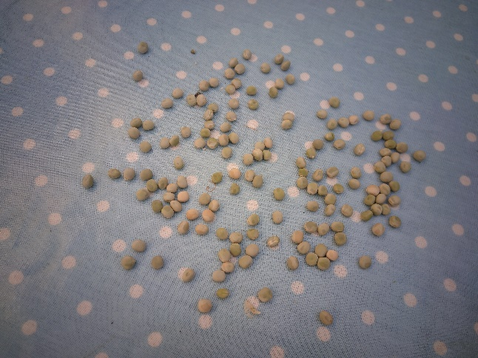
Back in the garden, things did not go entirely according to plan. I was eager to treat the sprouted peas as ‘early peas’ and just to make sure I covered the single row with a tunnel cloche. I miscalculated the need for water and many of the plants died because the rain couldn’t get to them. I am still getting used to England after a lifetime of gardening in Wales!

The few that survived grew well and produced enough peas to sow again, but not enough to repeat the class exercise. Here they are dried and podded:

In the way of things, it was hard for me to calculate exactly how much time I had spent. Sprouting, preparing the trenches, a proportion of compost making, fixing supports, harvesting, drying. Probably not more than half an hour, and of course the yield would have been much greater for the same effort if I had not bothered cloching. Still learning!

