DRAFT

THE METAPHORICAL GARDEN

Peter Harper
Centre for Alternative Technology



Bismillahi ar-rahman ar-rahim
In the name of God, the compassionate, the merciful

So, famously, begins the Holy Quran. There is a Sufi tradition that, if you know how to read it, all the wisdom of the Quran is somehow enfolded in this single phrase, and the rest is just commentary.

Poets would understand this. But there is another tradition, more enigmatic still: that the essence of the Quran's message lies within the single dot which (in Arabic script) underlies the opening B. You can see this potent dot on the lower right of the script. Think about it.
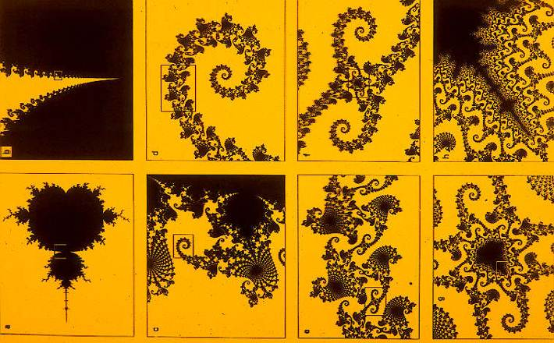
This is a religious equivalent of the Big Bang, where a singularity even smaller than Bismillah's dot gives rise to the whole universe. Similarly, in mathematics the Mandelbrot Set generates infinitely varied patterns from the implications of a single simple formula.
[Fig 2 here]

What is more intriguing still about the Mandelbrot set is that recurrent patterns, unexpected correspondences, occur at whatever scale we view it - and the same seems to be true of the universe, the part reflecting the whole and vice-versa, or in the hermetic nutshell, "As above, so below".

If the universe really is like this, almost anything could be mapped onto anything else and so become an analogy or a metaphor for it. But obviously some metaphors are more fruitful and user-friendly than others. Recently I have found myself applying these ideas to, of all things, the garden - an apparently inexhaustible source of correspondence and analogy that seems to work in any direction you care to take it - biological, social, philosophical, spiritual - even political.

At its most direct biological level, for example, the garden far outstrips Noah in providing a balanced sample of the range of living organisms. An alien spaceship could land in any garden, take a scoop of earth at random, and from this alone, alien scientists would be able to read all the essential features of life on earth. The scoop would contain millions of organisms of thousands of different types. But our aliens would quickly learn that all share fundamental patterns of genetics and metabolism and are derivatives of a basic type which still holds the system together, i.e., bacteria. They would know that all life on earth had a common origin. The three great domains of life—bacteria, archaea and eukarya, the last containing animals, fungi, plants, and protozoa—are all richly represented in the garden. Noah, God bless him, only sampled a fraction of a fraction of a fraction of one of them.

Whatever we might mean by the phrase "All life is one", in genealogical terms it is literally true, and I find an irresistible satisfaction in acknowledging a kinship—and weirdly, not so distant in the family tree as a whole—with my lettuces; or that once, long ago, the slugs and I shared a common ancestor, a population of real wet living breathing creatures with unknowable futures in them.

The garden reflects the biosphere in another way: it can be seen as a community of organisms bound together by flows of energy and materials, which is yet made up of component communities, physically smaller but equally complex; and these in turn.... Well, go into the garden and have a look. We have all had the experience of lying on the grass and getting caught up in the mini-jungle of a grass sward, looking at the mixture of plants and soil, organic detritus, small insects, worm-casts and so on. And it is of course, just as legitimate an ecosystem as a "real" jungle. It just depends how big you are. A hand-lens will reveal more details, and beyond that there are even smaller ecosystems, hard to see, but equally rich. The same regress of smaller and smaller communities applies to cracks in a wall, the bark of trees, rotting logs, the compost heap: any part of the garden.
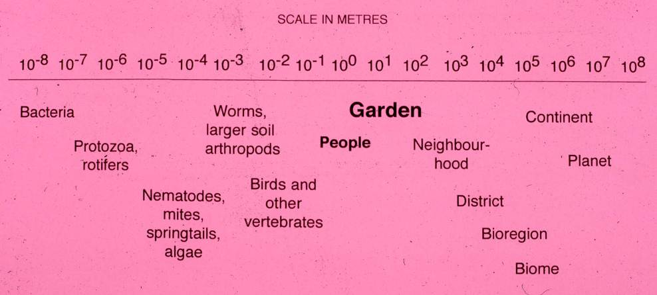

But if the garden is a composite of diverse communities, it is also itself a component of larger systems: interbreeding local populations, a bioregion defined by its climate and history, a continental system, on up to the biosphere which links all its components by global cycles of gases, water and minerals. This global system is so uncannily analogous to a self-regulating organism that it has been given a name, "Gaia", after the ancient Greek goddess of the Earth. In scale, the garden is midway between microbes and Gaia, but is itself a sort of mini-Gaia: the part represents the whole.
[Fig. 3 here]

The garden has taught me a lot about the nature of knowledge itself. What is really true out there and what are the best ways to discover it? Measurement and analysis are crucial tools and often give surprising results - with paradoxical implications. If you were able somehow to weigh all the different living things in the garden, it would come out like this: about 90% plants, and most of the rest microbes and fungi. And animals? Less than 2%, nearly all tiny invertebrate decomposers. This, for sure, is not what we were taught at school, and doesn't match our perceptions or workaday beliefs. We tend to see the living world as animals + plants with a few nondescript extras. But in ecological terms it's a plant/decomposer system in which the chief 'function' of animals seems to be to smash things up and to produce dung - to make surplus plant material more easily recycled by fungi and bacteria into nutrients for renewed plant growth. What? The mighty vertebrates, lords of creation, exist just to produce shit? Well you could certainly see it that way.
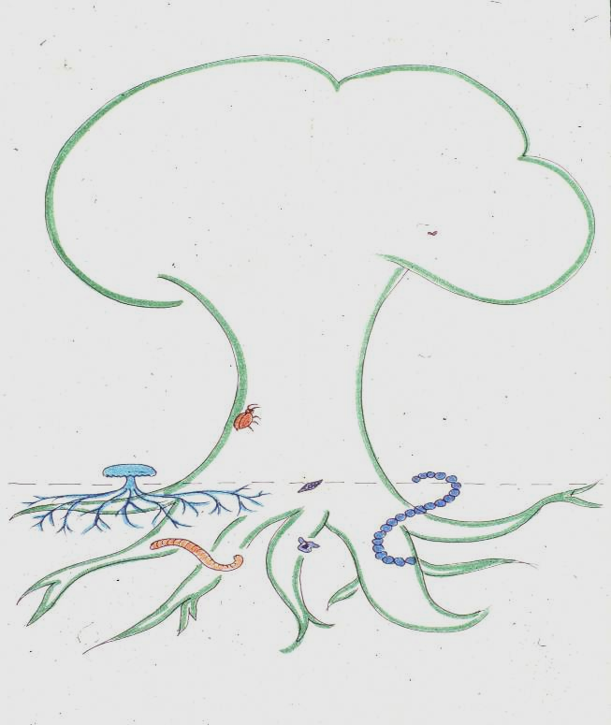
[Fig. 4 here]
Figure 4: The components of a typical terrestrial ecosystem scaled according to their biomass. You will need to look very hard to find the vertebrates.

What do I do with information like this? Certainly it has revolutionised the way I experience the garden - and the planet. But more generally it tells me that our habitual ways of seeing things are not the only ones, and that there is far more hidden from us than is apparent to the casual gaze. It reminds me that our pictures of the world are drastically conditioned by our perceptual physiology and "official" knowledge. What really is the "truth"? And who is to determine the official mythology - the one we teach our children?

Hard-nosed analysis is undoubtedly useful, and I would hate to find measurement, number-crunching and logic missing from my conceptual tool box. But it would be even worse to find these were the only ones available! As I have repeatedly discovered, many aspects of the garden respond only to quite the opposite approach: being still, not striving to know, just letting understanding settle like falling snow. Some perceptions are precluded by the harsh glare of analytic thought, just as you cannot use a searchlight to look for faint stars. As I see it, Truth is not something out there to be discovered once and for all, but an "understanding" between me and the world which can only be deepened by the apparent contradictions of different ways of knowing.

Perhaps it is not surprising to find biological lessons and analogues in the garden, but there are social and political ones too. One that has struck me rather forcibly is the close parallel between chemical fertilisers and 'junk food'. Here are two highly soluble sources of nutrients designed to deliver a quick result. They are cheap, and in their own terms, they work. All right in their place, we may say; the problems arise when they start to displace a significant fraction of the "proper diet" either for people or for soil. Then, little by little the overall health of the system starts to deteriorate.
[Fig. 5 here]

SOLUBLE FERTILISERS
What's the problem?
- They tend to displace healthy, balanced fertility for the soil.
- Alone, they do not contribute to underlying health of the soil.
- They lead to quasi-addictive dependency.
- They cause wider environmental problems.
Why do we use them?
- They are cheap.
- They are compact and easy to commercialise.
- They are promoted by a multi-billion-dollar industry.
- They are ready-to-use.
- They give instant gratification.

"JUNK FOODS"
What's the problem?
- They tend to displace a healthy, balanced diet.
- Alone, they do not contribute to underlying health.
- They are addictive.
- They cause wider environmental problems.
Why do we use them?
- They are cheap.
- They are compact and easy to commercialise.
- They are promoted by a multi-billion-dollar industry.
- They are ready-to-use.
- They give instant gratification.

In a similar way, we can compare garden and medical chemotherapy: pesticides and drugs. These are usually intended to correct specific problems and again we could defend occasional and judicious use. But both horticulture and medicine have gone mad with them, using them routinely as a cheap alternative to genuine health-promoting measures. People now accept this as normal. There are all sorts of side-effects and long-term damage, but the habit is too strong to break. In the worst cases it results in addiction, where a garden/body becomes wholly dependent on increasing doses, and if the chemicals are withdrawn there is a pathological collapse.
[Fig. 6 here]
------------------------------------------------------------------------
PESTICIDES

What's the Problem?
- They tend to be over-used.
- They become a substitute for long-term measures to promote health.
- They are often addictive.
- They stimulate resistance.
- They have numerous side-effects.
- They foster a shallow 'magic bullet' mentality which focusses exclusively on treatment of symptoms.
Why do we use them?
- They are cheap.
- They are easy to apply.
- They often give rapid results.
- There are often withdrawal symptoms if their use is discontinued.
- They are aggressively marketed by powerful industries.
- They are widely believed to be indispensible by scientific authority, by users and by the general public

MEDICAL CHEMOTHERAPY

What's the Problem?
- Drugs tend to be over-used.
- They become a substitute for measures to promote underlying health.
- They are often addictive.
- They stimulate resistance.
- They have numerous side-effects.
- They foster a shallow 'magic bullet' mentality which focusses exclusively on treatment of symptoms.
Why do we use them?
- They are cheap.
- They are easy to apply.
- They often give rapid initial results.
- There are often withdrawal symptoms if their use is discontinued.
- They are aggressively marketed by powerful industries.
- They are widely believed to be indispensable by scientific authority, by users and by the general public

In both these examples there is a political point to be made: that the widespread use of synthetic chemicals is driven largely by commercial pressures, permitting money and power to be concentrated and carefully directed. Huge sums are spent promoting the products and maintaining the illusion that they are effective and indispensable. Those systems of medicine and husbandry which avoid chemicals have the opposite characteristic: that money, effort and power are diffused. This is as it should be, but makes it difficult to exert a countervailing power - as we in the alternative movement are only too aware.

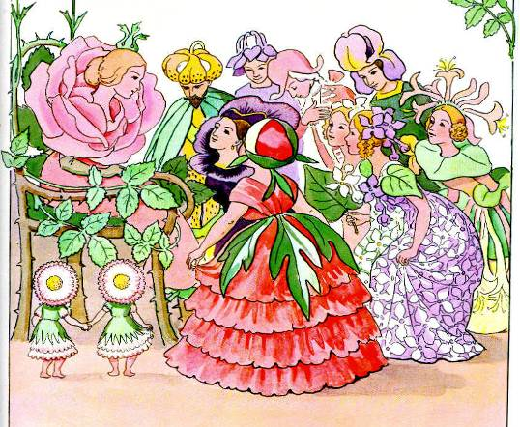
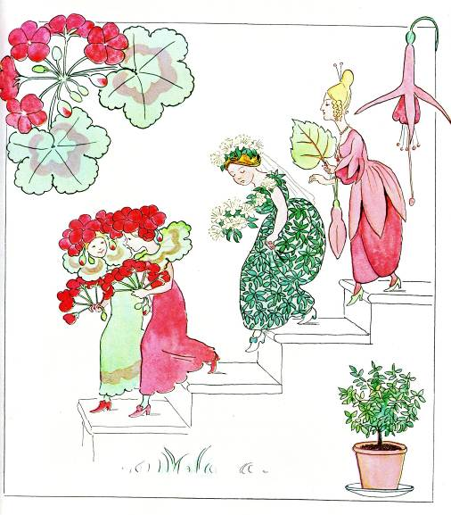
Here is another political parallel. In the kind of elegant formal gardens we like to visit on Sunday afternoons, everything has its proper place, which exactly mirrors the order of society a few hundred years ago, and which lingers on in popular taste. In fact I can illustrate this point very nicely with illustrations from a children's story published in Sweden in 1914. The best ground most visible from the house is given to plants with no utilitarian function - especially to those which do not exist in nature but are "cultivated" and "highly bred". This is the ruling elite, which cannot survive in the wild and needs constant attention and cossetting.

Slightly less genteel, so placed at a greater distance, are the herbaceous perennials and shrubs: the bourgeoisie.
[Figure 8 here]

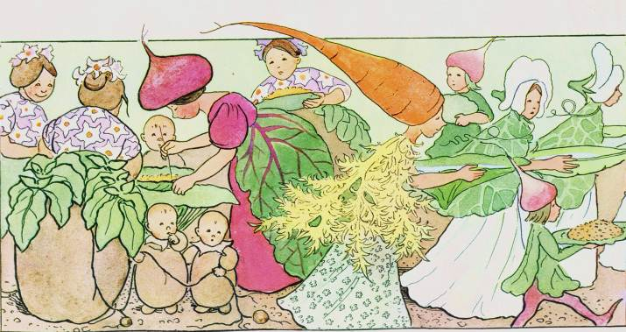
Further away still - perhaps tucked behind a hedge or trellis - is the vegetable garden. Although this too contains cultivated plants, they carry the crucial stigma of being useful, so rank below the pretensions of the herbaceous borders: they are the petty bourgeoisie and the artisan class: herbs and vegetables.

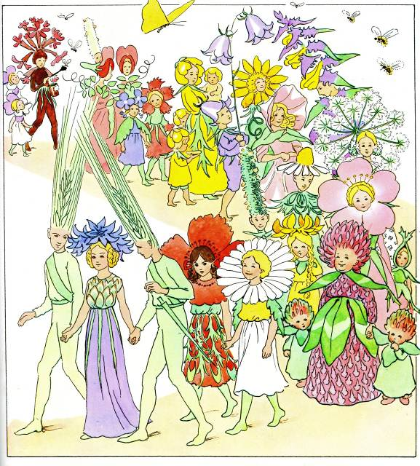
Beyond the garden gate, or in the wilder parts of a large estate, in the woods and streams and meadows are the yeoman peasants: wildflowers. Tolerated, even admired, as long as they stay in their place and behave themselves!

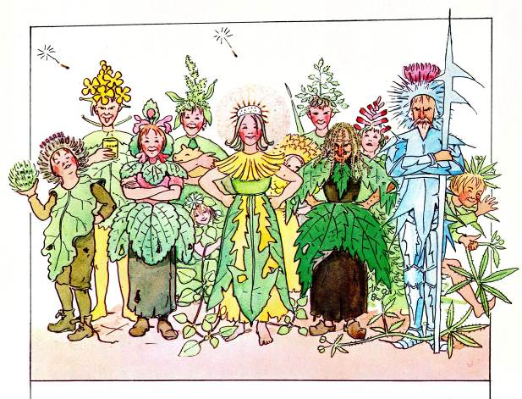
And then, the riff-raff, the urban mob: weeds. There is no place for them, and every effort is made to keep them at bay or eradicate them, by fair means or foul.

In the Victorian era this sort of arrangement was de rigueur, and we can see that the layout of the garden is remarkably similar to that of a royal banquet in medieval times. [Figure 13 here]

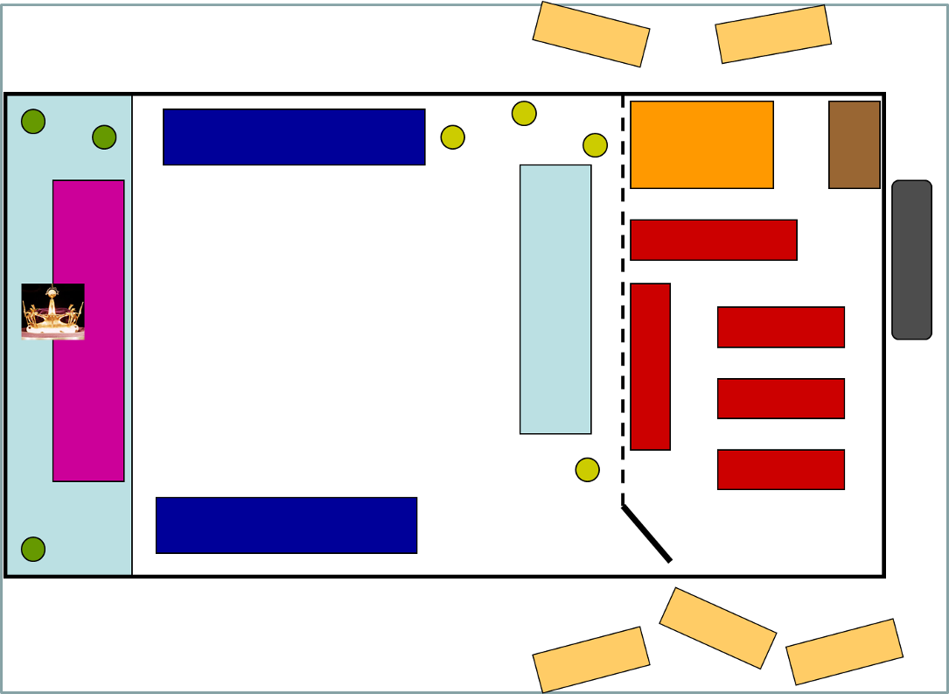
THE HOUSE/ROYAL FAMILY
HARDY PERENNIALS/
GENTRY, MERCHANTS
BEDDING PLANTS/NOBILITY
KITCHEN GARDEN/SERVANTS
SPECIMEN TREES/MEN AT ARMS,
WEEDS/RIFF RAFF URBAN MOB
WILDFLOWERS/
PEASANTS
VISUAL SCREEN TO MAINTAIN QUALITY NARRATIVE

But in a more egalitarian age the hierarchy is being dissolved. Perhaps it began with Gertrude Jekyll's forceful espousal of hardy perennials against the fussy bedding plants. Things started to relax. Now a full-scale revolution is in prospect. Permaculturists bring the edibles right up to the back door. Wildlife gardeners create all manner of natural habitats, and public open spaces have their "ecological landscapes". The value and beauty of native plants is widely recognised. The mania for total control at any cost is abating. As society becomes less hierarchical, so do gardens. All that remains is the emancipation of the weeds...and we're working on it!

This process of shifting the focus from humanity back towards nature crops up all over the place. It is as if several social and spiritual tendencies are coming together, urged by the same underlying current. Formal, highly controlled gardens - such as those of the middle east and Europe - are associated with societies whose gods live in the sky, having driven out the earth gods in former times. It is also true of the Confucian tradition in China, possibly the high point of "cultivation" in the human sense.

In contrast, Earth-centred or mystical religions tend to have "naturalistic" styles of gardening, or no gardens at all that we would recognise as such. There is a blurring of the distinction between wild and managed; and "gardens" may gain religious functions: as sanctuaries or as representing the mind of God. The healing power of nature is recognised.

I have always felt over-controlled gardens rather dull. The brain picks up the patterns, pigeon-holes them and that's the end of it. There is no further challenge. The fascinating quality of real nature is its order-within diversity. It is inexhaustibly complex, but undisputedly ordered. The order is, however of a very subtle kind, and exists at many levels, mostly hidden but awaiting recognition by the prepared mind.

Science seems to be reaching the same point. With quantum theory having loosened the stays, as it were, much of this subtle order in nature is now being addressed under the heading of "chaos" or "complexity" theory. Life in particular inhabits a cosmic mathematical "space" on the boundary between rigid order and chaos - and needs a bit of each. To stray too far in either direction risks death by frost or fire. I believe that, as human beings, we need to contemplate the complexity which arises from this balancing act; human artifacts, however well-crafted, mostly lack the essential dynamic quality. We need this in the slightly fuzzy way we need vitamins: you can go without for quite a long time without them, but eventually things start to fall apart - in this case not physically, but spiritually. The garden, as a microcosm of nature, can provide this vitamin in abundance if it is not straitjacketed by misplaced control.
[Fig 14 here]
I think this is why nature is so perennially fascinating to us. It obeys all the rules, maintains its dynamic balance, and still comes up with endless variations. Here is a metaphor for all true morality: a dynamic tension between conflicting requirements. To codify it is to kill it; to pick one side and maximise it is a fatal parody.

For me one of the most powerful "garden parables" comes from the recognition of the role of decomposers I mentioned earlier. The decomposers are everywhere and essential: without them the whole system would seize up; and yet we do not know about them, we are not told about them except in the most oblique terms. When we deign to notice them at all, they and their work are viewed with distaste or even horror: they are creepy-crawlies, germs, scavengers, vermin. They deal in decay, corruption, death, ordure, carrion, mould, rottenness. This revulsion is almost universal, but in another light can be seen as a projection of an infantile refusal to face the realities of death and decay, or as a species to face honourably the need to clean up after ourselves.

This metaphor is starkly underlined by the basic fact that most of the decomposition processes take place under the ground. The symbolism is almost too accurate. We are not conscious of the underworld because it is in a sense the earth's unconscious - a dark, hidden region of death and dissolution, harbouring mysterious processes of alchemical transformation. We are blinded to it by the "conscious" world above ground, of light, warmth, colour, movement, reason. Just as we ignore or denigrate the dark side of nature, so too do we try to suppress the dark side of our own natures. But just as the natural order would grind to a halt without its dark side, so would we: The dark side suppressed raises demons and dreadful pathologies. There can be no growth without decay, no resurrection without death.
[Fig. 15 here]

THE LIGHT AND THE DARK WORLDS: SYMBOLISM OF THE UNDERWORLD

ABOVE GROUND SYMBOLISES | BELOW GROUND SYMBOLISES
Light | Dark
Extension, perspective | Enclosure, restriction
Air Fire | Earth, water
Vision, colour, | Touch, smell
Warmth | Coldness
Reason, sophistication | Instinct, the primitive
Dexter | Sinister
Transparency, clarity | Latency, ambiguity, the occult
Algorithms | Magic, symbols
Consciousness | The Unconscious
Growth, healing, cleanliness | Decay, corruption, rotting, filth
Creation, building up | Dissolution, breaking down
Big, attractive creatures | Small, repulsive creatures
Respectable livelihoods: grazing, hunting, gathering | Disreputable livelihoods: scavenging, coprophagy, body-snatching, parasitism
The Olympian gods, "beautiful people", ignoring the Dark Side of creation and heading for their Götterdämmerung | The dark gods, blind, lame, dwarfed, disfigured, planning the downfall of the Olympians

Resurrection is a natural theme in any garden; recovery from setbacks; growth after dormancy; the irrepressible return of spring. Things come back in cyclical ways, but always slightly different. The cycle of seasons is one of the celebrated pleasures of gardening, but I have also become attuned to daily cycles. I am astonished at how different the garden feels at different times of day, and how this sense of hourly differences has steadily become stronger. It is a great source of pleasure for some reason, but has taken me years even to notice!

The parallels I have drawn between gardens and other spheres of life are just the merest sample - it can go on and on. I am not sure why gardens should be so fruitful a source of allegory. Perhaps it is because they are the most intimate of all the places where the human and natural worlds come face to face. Houses are so comfortable these days; we become cocooned in artificial things. The simple act of walking through the back door into the garden is a rite of passage which takes me into another world, the open sky, the plants, the earth beneath my feet. Then - I can't help it - the whole thing bursts into symbols, metaphors, correspondences, parables, allegories: as if the garden is an extension of my mind.

Or am I an extension of the garden?



